Jawahar:-

ng-app-->Auto bootsrap of angular js application.Root element of application.You have multiple ng-app perpage but requires manual bootsrap.

ng-init

ng-if

ng-bind -->To print the value of variable.We are accessing object from scope not variable.

ng-model ==>value updated on each keypress.Two way databinding.

We cannot apply paragraph into paragraph<p>.We will use tag span.

{{username}}-->To print the value of variable.

Controller=>To process business logic.

ng-controller

console.log(angular);

--Example For Controller

<div ng-controller="MainCtrl">

</div>

var module=angular.module("myapp",[])

module.controller("MainCtrl",Main);

function Main(){

console.log("hello world");

}

Module=A module is a collection of directives,cotrollers and other stuff.

Global place for creating,registring  and retreiving angular module.

//create  new module

var module=angular.module("myapp",[])

//Use Module

<html ng-app="myapp">

//Every Angular application has default global scope called the root scope.Outside any controller it is the root scope that applies.

//In multiple nested controller there is a problem to figure out

// from which scope value comes out in large application so syntaxControllerAs comes in picture.

ControllerAsSyntax-

<div ng-controller="Ctrl1 as c1"

and remove $scope from function and use this.propertyname.

Angular-2

Declare variable in angular.

private count:number=0;

main.ts starting point of application.

karma-conf.js ==>testrunner for javascript

typescript==translates==>javascript

export keyword for class is used to make class public.

app.module.ts--Main Module

## Bootstrap in main.ts

There are many ways to bootstrap an application. The variations depend upon how you want to compile the application and where you want to run it.

In the beginning, you will compile the application dynamically with the Just-in-Time (JIT) compiler and you'll run it in a browser. You can learn about other options later.

The recommended place to bootstrap a JIT-compiled browser application is in a separate file in the src folder named src/main.ts

#### src/main.ts

COPY CODE

import{ platformBrowserDynamic }from'@angular/platform-browser-dynamic';

import{AppModule}from'./app/app.module';

platformBrowserDynamic().bootstrapModule(AppModule);

This code creates a browser platform for dynamic (JIT) compilation and bootstraps the AppModule described above.

The bootstrapping process sets up the execution environment, digs the root AppComponent out of the module's bootstrap array, creates an instance of the component and inserts it within the element tag identified by the component's selector.

The AppComponent selector — here and in most documentation samples — is my-app so Angular looks for a <my-app> tag in the index.html like this one ...

COPY CODE

<my-app><!-- content managed by Angular --></my-app>

To generate component==>ng g c componentname

To generate service====>ng g s componentname

@Injectable for Service

@component for component.

Directive==>1-Structural  2-Attribute

<ng-template> for if else

RouterLink replaces href which has better performance and it download js first time and not later.

There are three types of directive.

Component---Which have template.

Structural---Which can modify/ADD/REMOVE the template.

Attribute ---Which can change the appearance or behaviour of element.==>[]

Q=diffrenece between ngIF and *ngIF?

Ans=ngIf is the directive. Because it's a structural directive (template-based), you need to use the *prefix to use it into templates.

*ngIf corresponds to the shortcut for the following syntax ("syntactic sugar"):

<template [ngIf]="condition">

<p>

Our heroes are true!

</p>

</template>

Equivalent to:

<p *ngIf="condition">

Our heroes are true!

</p>

--Difference between *ngFor and ngFor

You can use ngFor as a shorthand

<li *ngFor="let item of items">{{item.name}}</li>

or as the longhand version

<template ngFor let-item="$implicit" [ngForOf]="items">

  {{item.name}}

</template>

------------------------------------

@NgModule==>

                imports-BrowserModule,RouterModule,HttpModule

                declarations:components, directives and pipes

                Bootstrap:AppModule

                providers:Service

ngOnInit()===>This is called after all properties are initialised.

#How to define Method

@Injectable()

export class appService {

   getApp(): string {

      return "Hello world";

   }

}

===>The logic not related to view reside in Service.

===>Component is a javascript class with metdadata attach to it.

===>Router is used for navigation and tell the which component will view viewd.

import{NgModule}from'@angular/core';

import{BrowserModule}from'@angular/platform-browser';

import{AppComponent}from'./app.component';

import{Appproduct}from'./product.component';

import{AppInventory}from'./Inventory.component';

import{RouterModule,Routes}from'@angular/router';

const appRoutes:Routes=[

{ path:'Product', component:Appproduct},

{ path:'Inventory', component:AppInventory},

];

@NgModule({

imports:[BrowserModule,

RouterModule.forRoot(appRoutes)],

declarations:[AppComponent,Appproduct,AppInventory],

bootstrap:[AppComponent]

})

exportclassAppModule{}

First we need to import Routes and RouterModule.

Add the const because we know that these variables will not change.add the path and component we can define redirect matches etc different type of attribute.

Then we should resister in import of app.module.ts RouterModule.forRoot(appRoutes),

import{Component}from'@angular/core';

@Component({

selector:'my-app',

template:'

<ul>

<li><a [routerLink] = "['/Product']">Product</a></li>

<li><a [routerLink] = "['/Inventory']">Inventory</a></li>

</ul>

<router-outlet></router-outlet>'

})

exportclassAppComponent{}

router link is used to create the link in angular.

Router-outlet is used where all component will place

But more importantly, we can see that whenever we try to go to the path lazy,

we are going to lazy load a module conveniently called LazyModule. Look closely at the definition of that route:

<a [router]

const routes: Routes = [

  { path: '', redirectTo: 'eager', pathMatch: 'full' },

  { path: 'eager', component: EagerComponent },

  { path: 'lazy', loadChildren: 'lazy/lazy.module#LazyModule' }

];

We can provide children of routes:

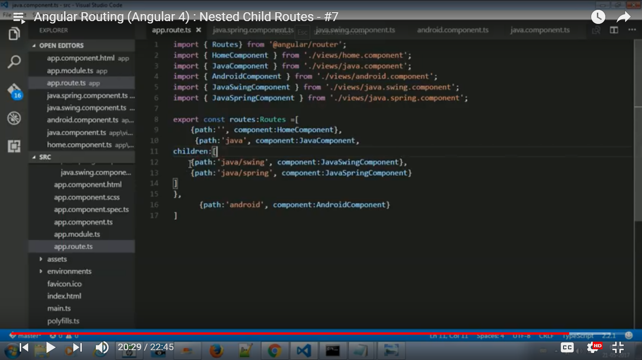

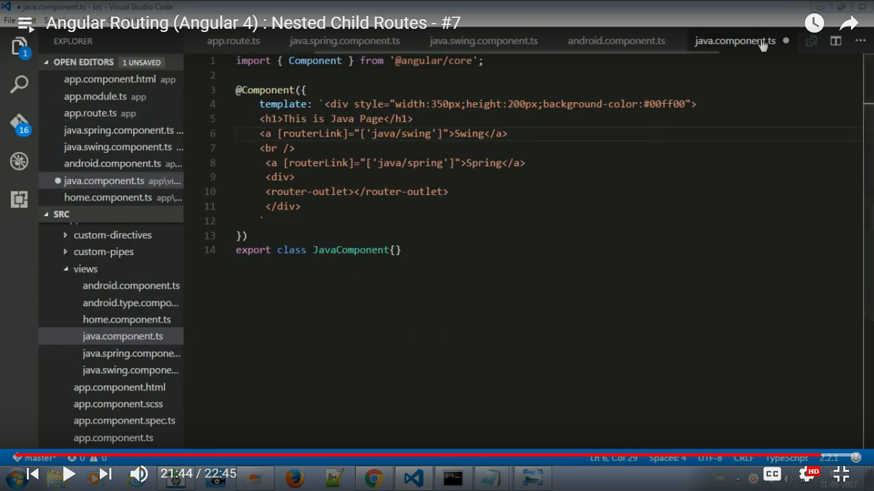

We can pass parameters in routes:

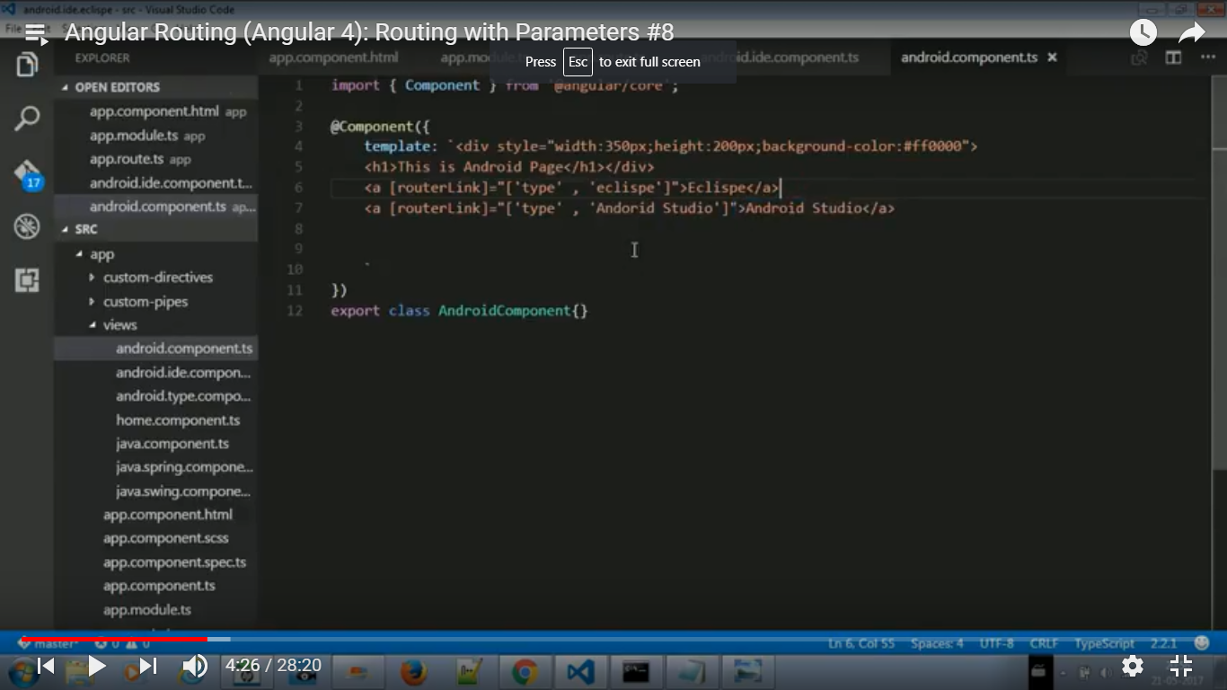

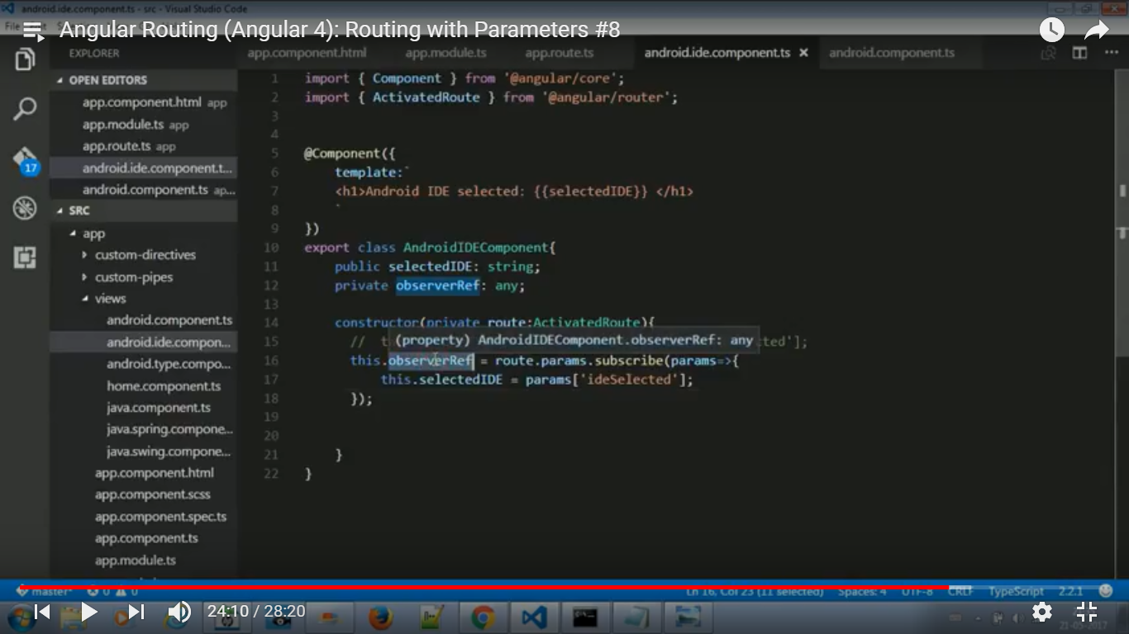

In above code objerber will not destroy so for gud practice when componenet will destroy then objectrver object will also close.

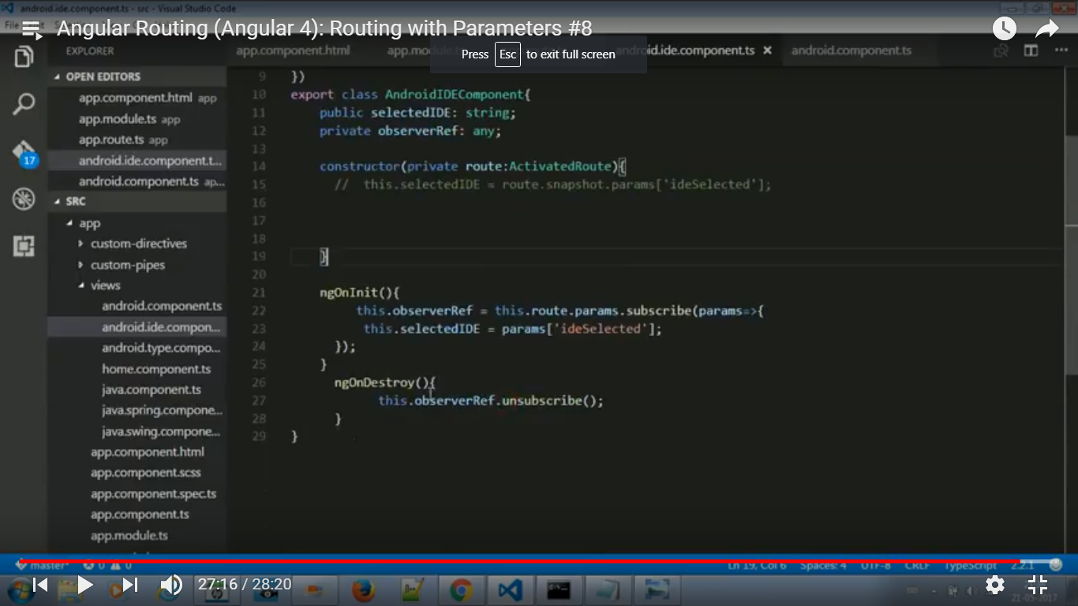

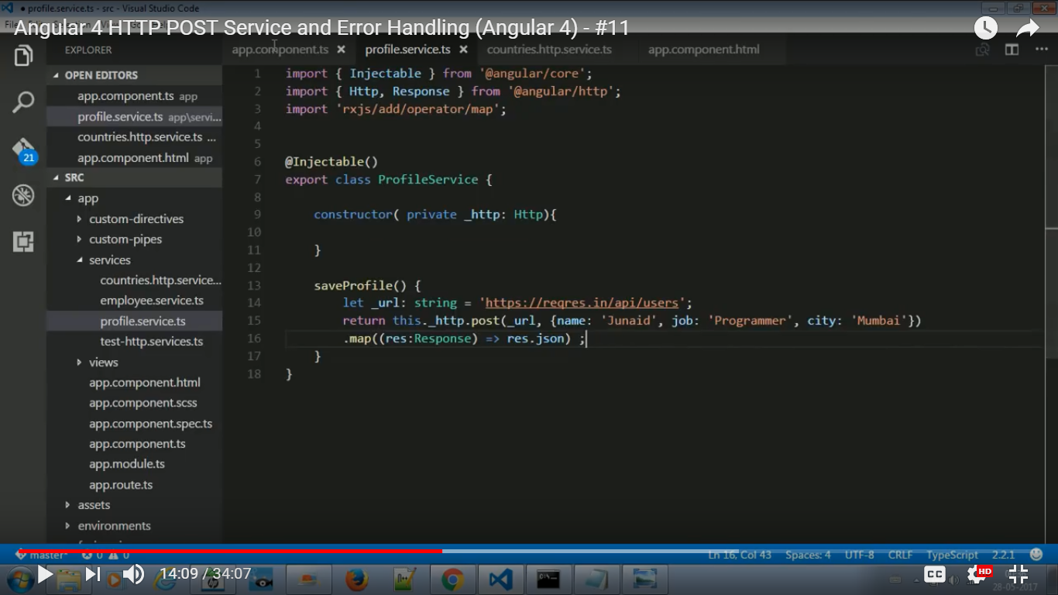

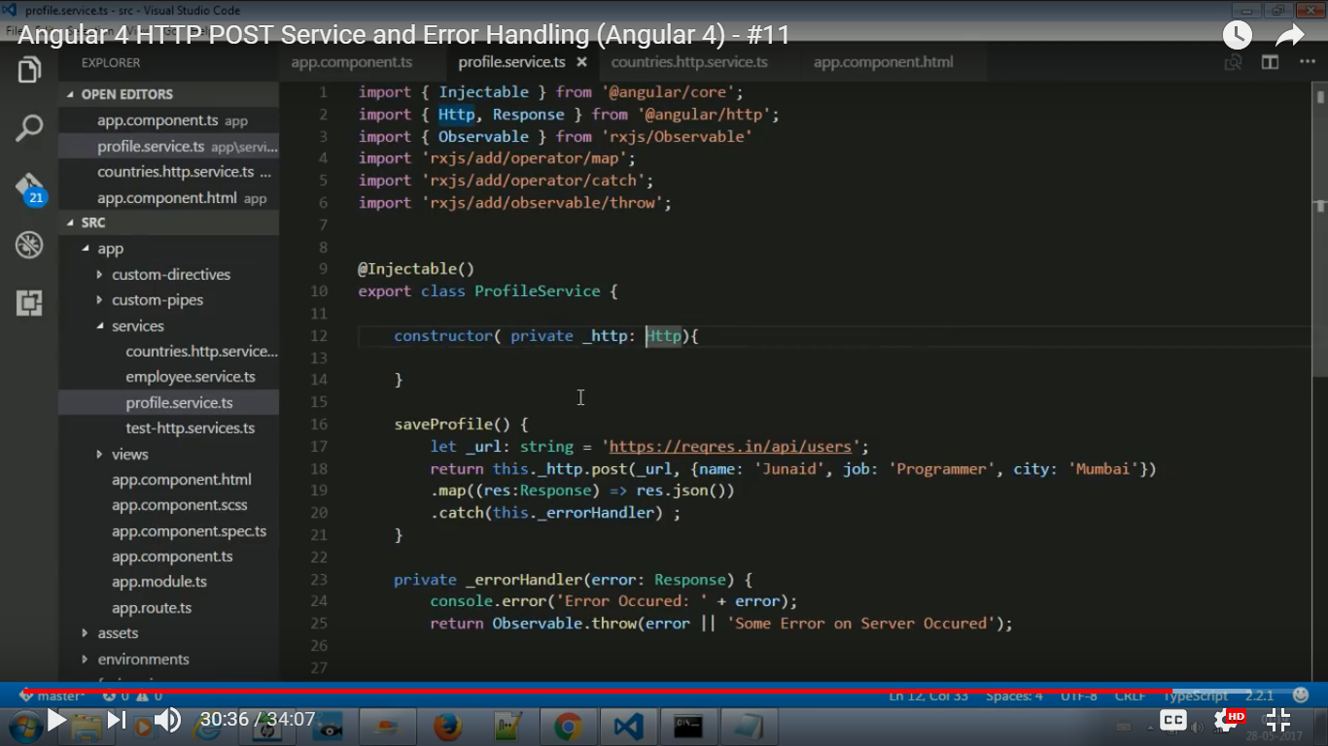



Attribute Directive

@Directive({

    selector: '[myUnderline]'

})

export class UnderlineDirective{

    constructor(

        private renderer: Renderer,

        private el: ElementRef

    ){}

  // Event listeners for element hosting

  // the directive

    @HostListener('mouseenter') onMouseEnter() {

        this.hover(true);

    }

    @HostListener('mouseleave') onMouseLeave() {

        this.hover(false);

    }

  // Event method to be called on mouse enter and on mouse leave

    hover(shouldUnderline: boolean){

        if(shouldUnderline){

        // Mouse enter   this.renderer.setElementStyle(this.el.nativeElement, 'text-decoration', 'underline');

        } else {

    // Mouse leave           this.renderer.setElementStyle(this.el.nativeElement, 'text-decoration', 'none');

        }

    }

Structural Directive

@Directive({ selector: '[myIf]' })

export class IfDirective {

  constructor(

    private templateRef: TemplateRef<any>,

    private viewContainer: ViewContainerRef

    ) { }

<https://www.code-sample.com/2015/04/angularjs-v-2-0-interview-questions-and.html>

# LifeCycle hooks

                ngOnChanges()

                ngOnInit()

                ngDoCheck()

                ngAfterContentInit()

                ngAfterContentChecked()

                ngAfterViewInit()

                ngAfterViewChecked()

                ngOnDestroy

or

A component has a lifecycle managed by Angular itself. Angular manages creation, rendering, data-bound properties etc. It also offers hooks that allow us to respond to key lifecycle events.

Here is the complete lifecycle hook interface inventory:

* ngOnChanges - called when an input binding value changes
* ngOnInit - after the first ngOnChanges
* ngDoCheck - after every run of change detection
* ngAfterContentInit - after component content initialized
* ngAfterContentChecked - after every check of component content
* ngAfterViewInit - after component's view(s) are initialized
* ngAfterViewChecked - after every check of a component's view(s)
* ngOnDestroy - just before the component is destroyed

# class Person

{

  name: string;

  nickName?: string;

}

In the above example, an instance of Person  is guaranteed to have a name, and might optionally have a nickName

# To Access child components from DOM

There are other means of accessing and interfacing with child components, but if you simply

need to reference properties or methods of a child, this can be a simple and straightforward

method of doing so

<rio-profile  #profile></rio-profile>

My name is {{ profile.name }}

#Custom Pipe

@Pipe({

  name: 'formatFileSize'

})

export class  FormatFileSizePipe implements PipeTransform {

  transform(sizeInBytes: number, longForm: boolean): string {

# Difference between Promises and Observables.

Promises==>Emits a single value,Not lazy,Cannot be cancelled.

Observables==>Emits multiple value over periods of time.Lazy an observable is not called untill we subscribe to the Observable.

Can be cancelled by using unsubscribe() method.Observable provides operation like map,filter,reduce,foreach,retry,retrywhen etc.

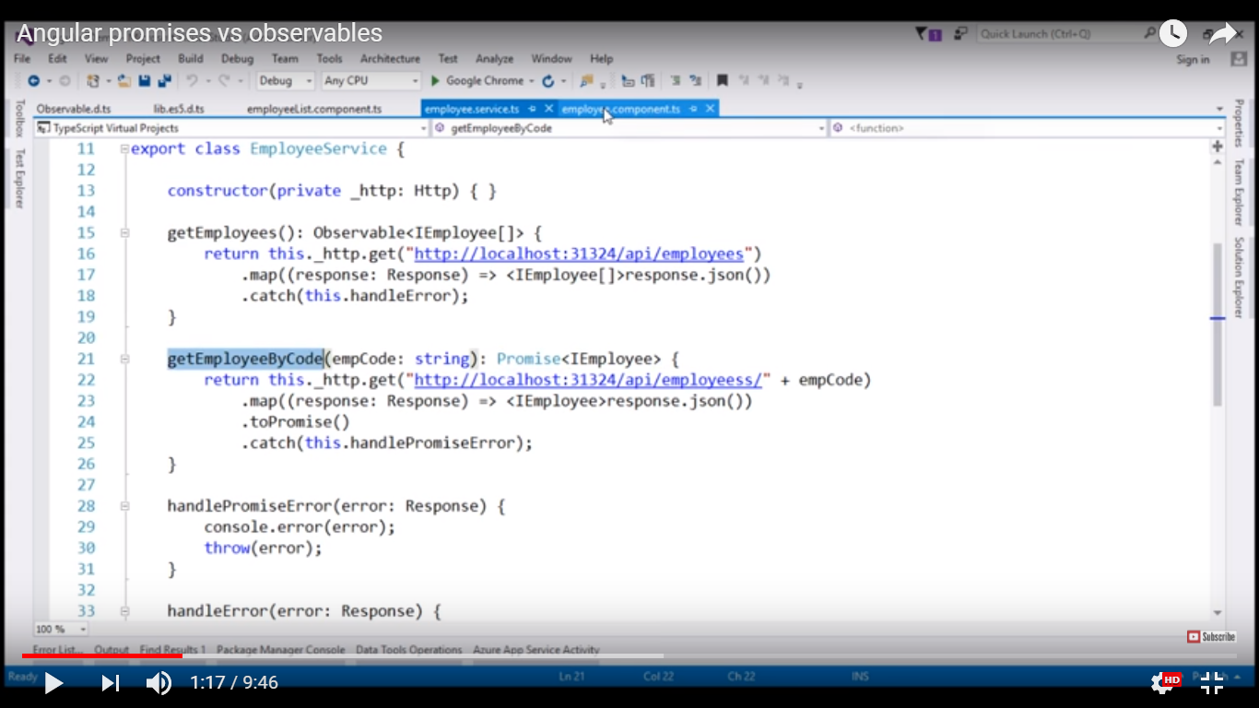

# Difference between @Inject and @Injectable

You really should only use @Inject for situations where the injectable token is not a class. If you are unfamiliar with what a token is, it is basically what Angular uses to recognize what to inject. For example

providers: [

  AuthService,

  { provide: Http, useValue: new CustomHttpImpl() }

]

Here we have two different providers, the AuthService and the CustomHttpImpl. With the AuthService the token is AuthService. This means that we inject AuthService, using obviously the AuthService type

constructor(private authService: AuthService) {}

With this constructor, Angular knows to look for the AuthService with the token AuthService.

In the second provider, we provide a CustomHttpImpl but this time we use the token Http. So we cannot inject CustomHttpImpl we need to inject Http, since that is the token

// this will actually be the CustomHttpImpl, not Angular's Http

constructor(private http: Http)

// error: No provider for CustomHttpImpl

constructor(private http: CustomHttpImpl)

So you can tell from this that the tokens are all classes, which is enough for Angular to figure out to how to inject.

But let's say we have a String, or an Array of something we want to inject. We can't tie that to any class token, so we need to create an artificial token

import { OpaqueToken } from '@angular/core';

let numbers = [ 1, 2, 3, 4 ];

let config = '{ "some": "json", "config": "data" }'

const NUMBERS = new OpaqueToken('app.numbers');

const CONFIG = new OpaqueToken('app.config');

Now we have tokens for the items we want to inject. When we configure the providers, we use those tokens, and when we inject, we @Inject(TOKEN)

providers: [

  { provide: NUMBERS, useValue: numbers },

  { provide: CONFIG, useValue: config }

]

constructor(@Inject(NUMBERS) numbers: number[], @Inject(CONFIG) config: string)

UPDATE

Now, with Angular 4, we should use InjectionToken rather than OpaqueToken

References:https://stackoverflow.com/questions/40017679/what-is-the-difference-between-inject-vs-constructor-injection-as-normal-parame/40019237#40019237

#@Input && @Output

<https://www.infragistics.com/community/blogs/dhananjay_kumar/archive/2016/12/13/communication-between-components-using-input-in-angular-2.aspx>

If you are not doing unit testing or you have simple form, go ahead with template-driven forms.

# FormGroup

Tracks the value and validity state of a group of FormControl instances.

A FormGroup aggregates the values of each child FormControl into one object, with each control name as the key. It calculates its status by reducing the statuses of its children. For example, if one of the controls in a group is invalid, the entire group becomes invalid.

FormGroup is one of the three fundamental building blocks used to define forms in Angular, along with FormControl and FormArray.

# Difference between Observables anf promise.

# Difference between @viewChild and @viewChildren

# Change Detection

# AOT

# webpack

# strict mode

<http://www.talkingdotnet.com/difference-between-angular-1-x-and-angular-2/>

<https://coryrylan.com/blog/angular-form-builder-and-validation-management>

<https://getfreetutorial.com/udemy-angular-4-complete-guide/>

<https://github.com/csotomon/Angular2-AdminLTE>

<http://www.dotnetcurry.com/angularjs/1366/angular-4-app-typescript-bootstrap>

<https://www.concretepage.com/angular-2/angular-4-crud-example>

angular js compilers

redex firebase

ng-container directive

@injectable

vs

@injact

@viewchild

@viewchildren

@input

@output

EventEmiter class

@objervable & promises

closer

Event bubling in java sript

routing

injectable

how to create singleton object in AngularJs?

reactive

template

banana box

routing

redirect

Angular2 life cycle

Difference btween ngOninit and constructor?

What is rxjs map in angular

Q=Install angular/cli ?

Ans= >npm I -g @angular/cli

After install angular cli we can check with

>ng -v

To create new application on angular

>ng new myFirstApp

After some it will complete go to your foulder

myFirstApp>code .

write code and dot(.) and press enter automatically your code will open in visual studio code

For test unit testing ;

>ng test

Automatically whole unit test will execute and give the report in graphical format. Browser will open automatically.

For execute end to end test press:

>ng e2e

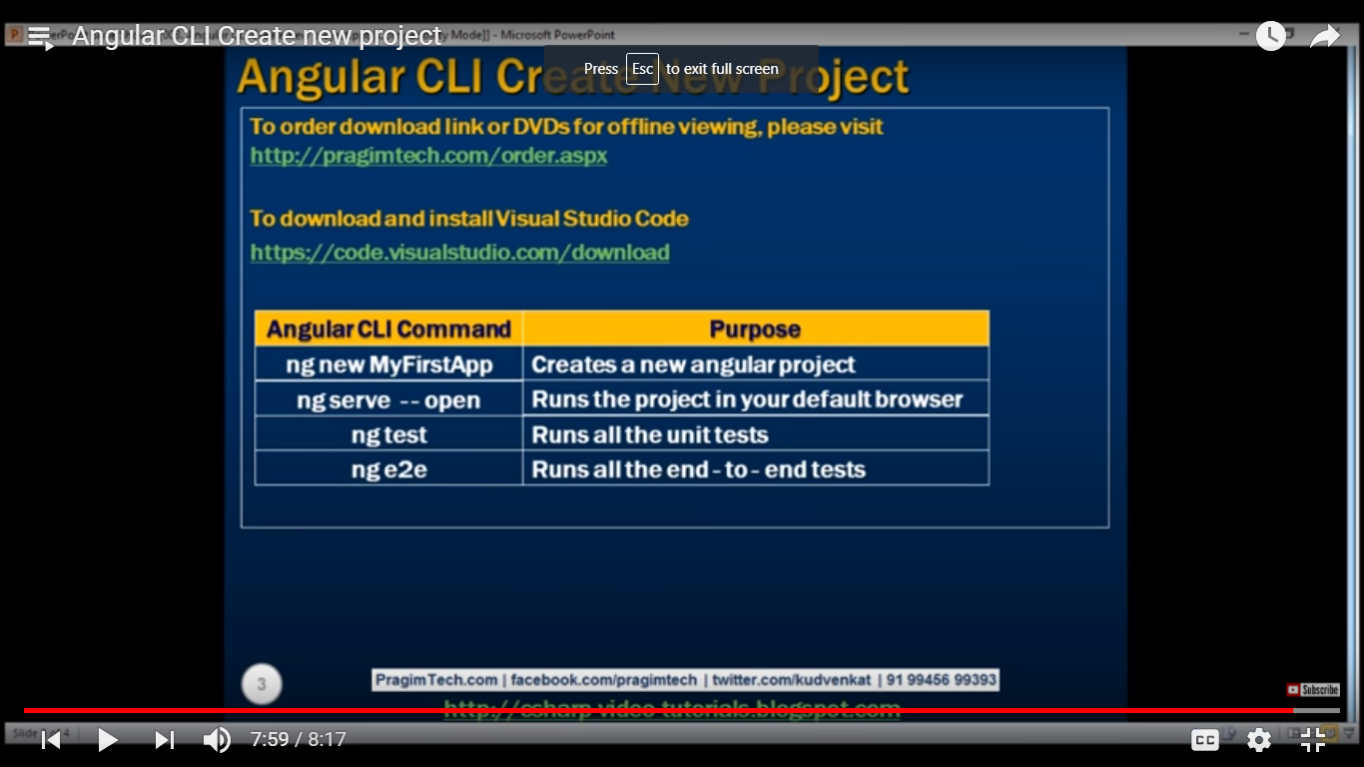

Help?

>ng - -help

For copy all commanrs

>ng - -help | ciip

Automatically whole help will copy to clipboard

And we can past in notepad or anywhere

>ng - - help > abc.txt

Help will automatic copy in containing folder.

Q=difference between dev and prod build of angular?

Ans=

>ng build - -dev

>ng build - - prod

-> in development build source map is available but in production build is not available.Source map means source code will not available. In both build whole js and css will combine in main file.

But in dev environment we can debug and change the source.

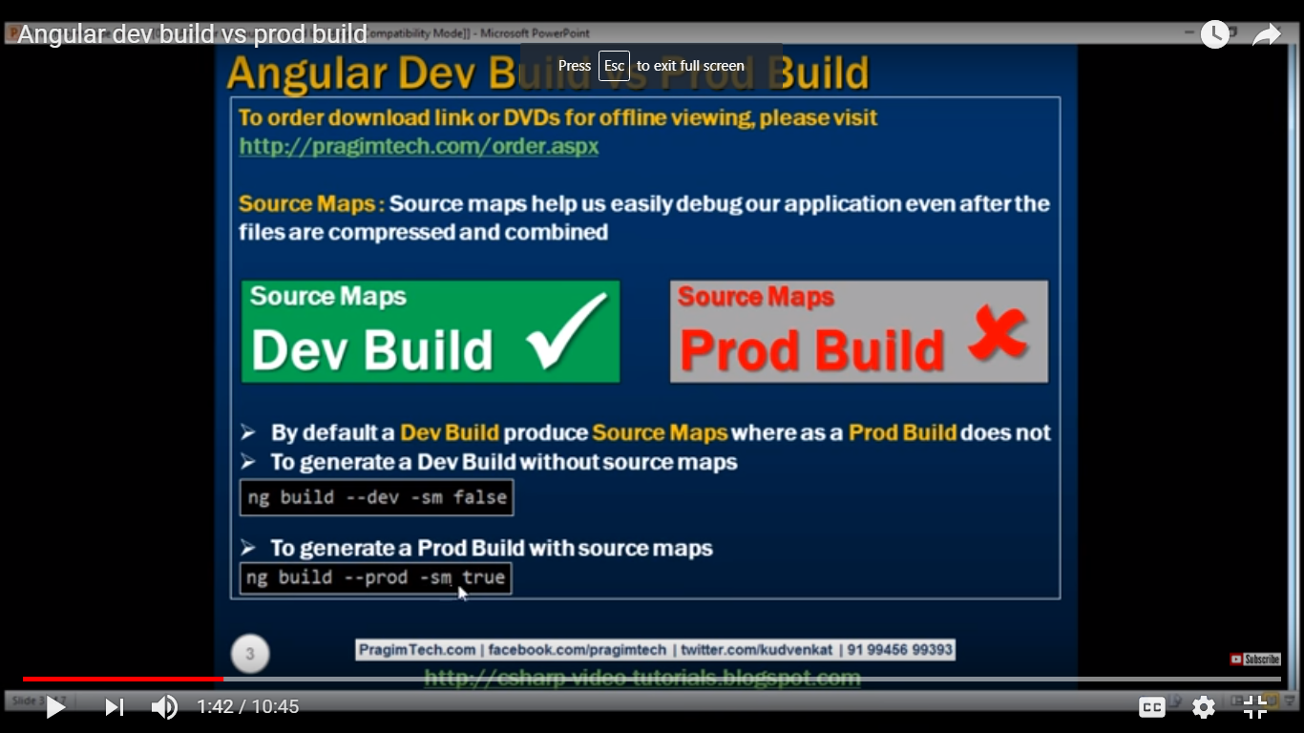

->minification and uglification is not available in dev.

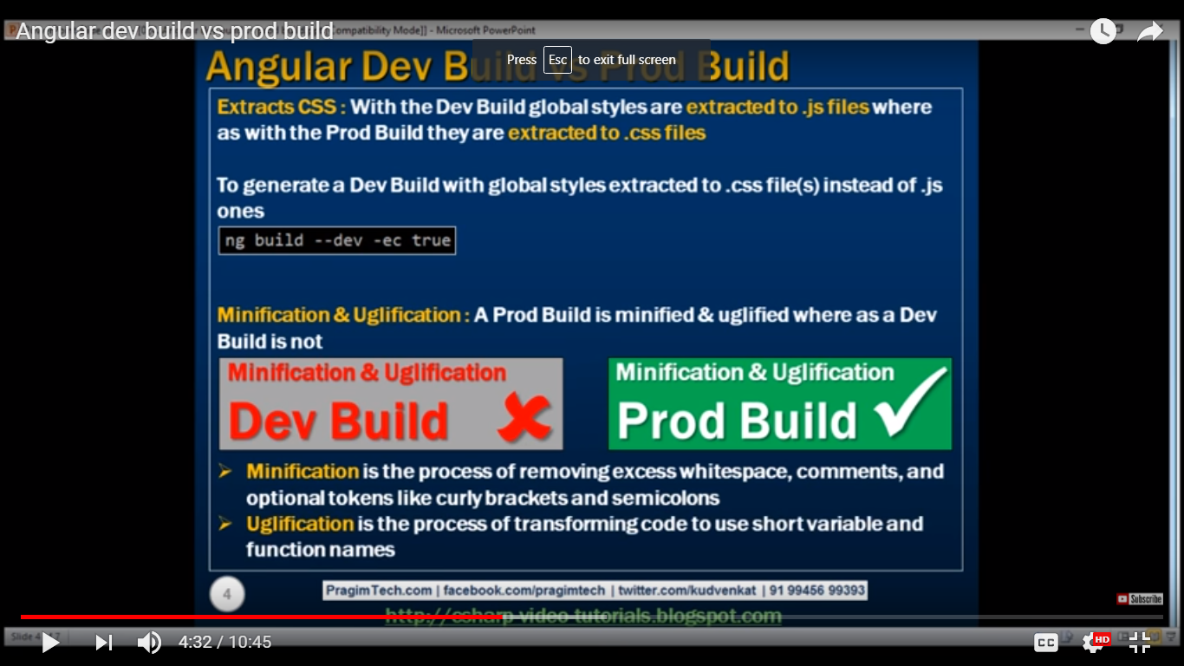

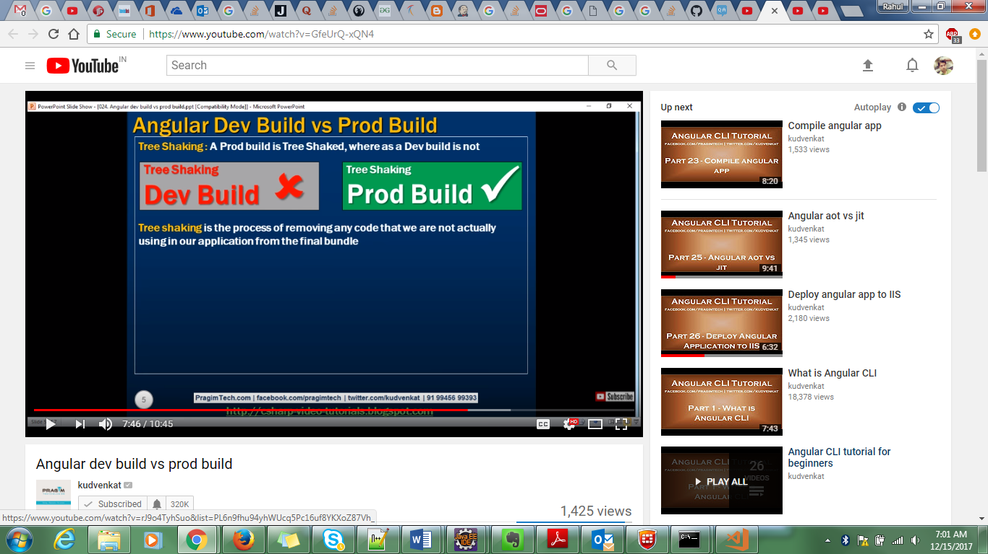

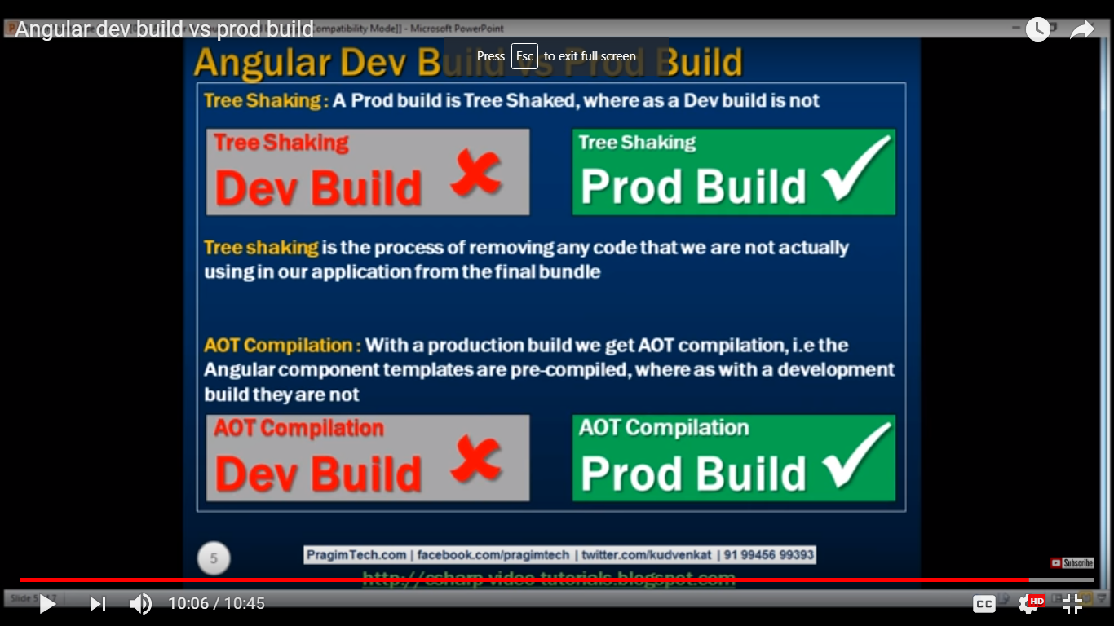

Q=what is component?

Ans=A component in angular is a class with template and decorator.

>template

>class

>decorator

* **Template** − This is used to render the view for the application. This contains the HTML that needs to be rendered in the application. This part also includes the binding and directives.
* **Class** − This is like a class defined in any language such as C. This contains properties and methods. This has the code which is used to support the view. It is defined in TypeScript.
* **Metadata** − This has the extra data defined for the Angular class. It is defined with a decorator.

>**Angular Interpolation>**

This is data binding. In angular there are three types of databinding.

1>one-way-data binding : From Component to view template

2>one-way-data-binding: From view template to component.

3>Two way data binding:From component to view template and from view template to component.

HTML Attribute vs Dom property:

1>attribute defined by HTML. And properties are defined by DOM.

2>Attributre initialize dom ptoperties , Once the initialization complete the attributes job id done.

3>properties value can change where as attribute value can not.

Q=Angular pipe:

It is just like filter In angular js filter

Name | uppercase

Date | date:fullDate | uppercase

{{emplolyee.dataOfBirth Date | date:’dd/MM/yy’}}

{{emplolyee.salary | currency : ‘USD’ : true:’1.3-3’}}

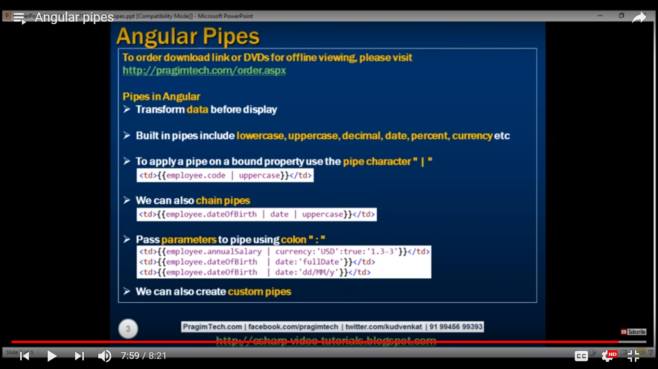

Angular custom pipe:

If we have some specific requirement the we will implement our custom pile.

Ex: we have employee name and gender. I want to change employee name according to gender. I gender is female Miss should me append with her name and if employee name is male then Mr will append with his name.

Import {Pipe , PipeTransform} from ‘@angular/Core’

@Pipe({

Name:employeeTitle

})

export class EmployeeTitlePipe implements PipeTransform

{

transform(value:string , gender:string):string{

if(gender.toLowerCase() == ‘male’){

return ‘Mr.’ + value;

}

else{

return ‘Miss’ + value;

}

}

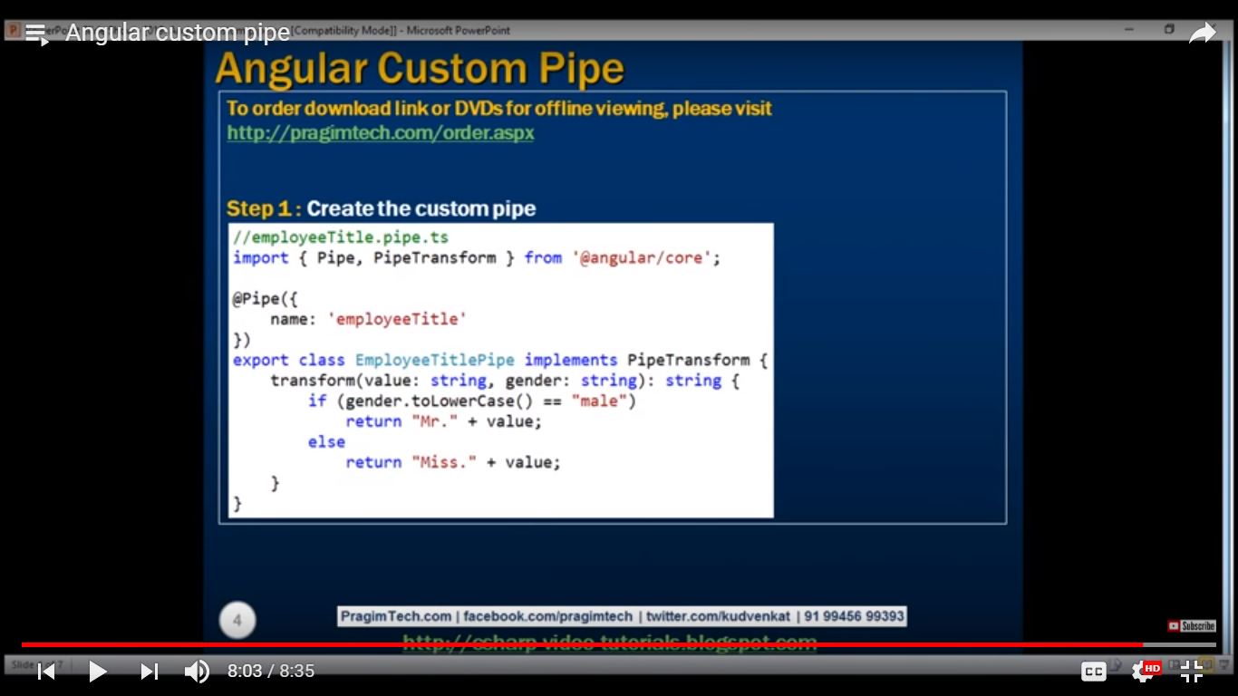

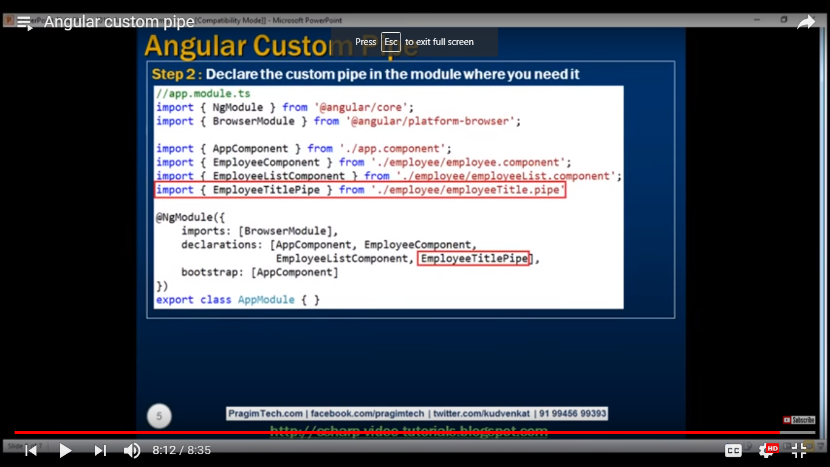



Create pipe with parameter:

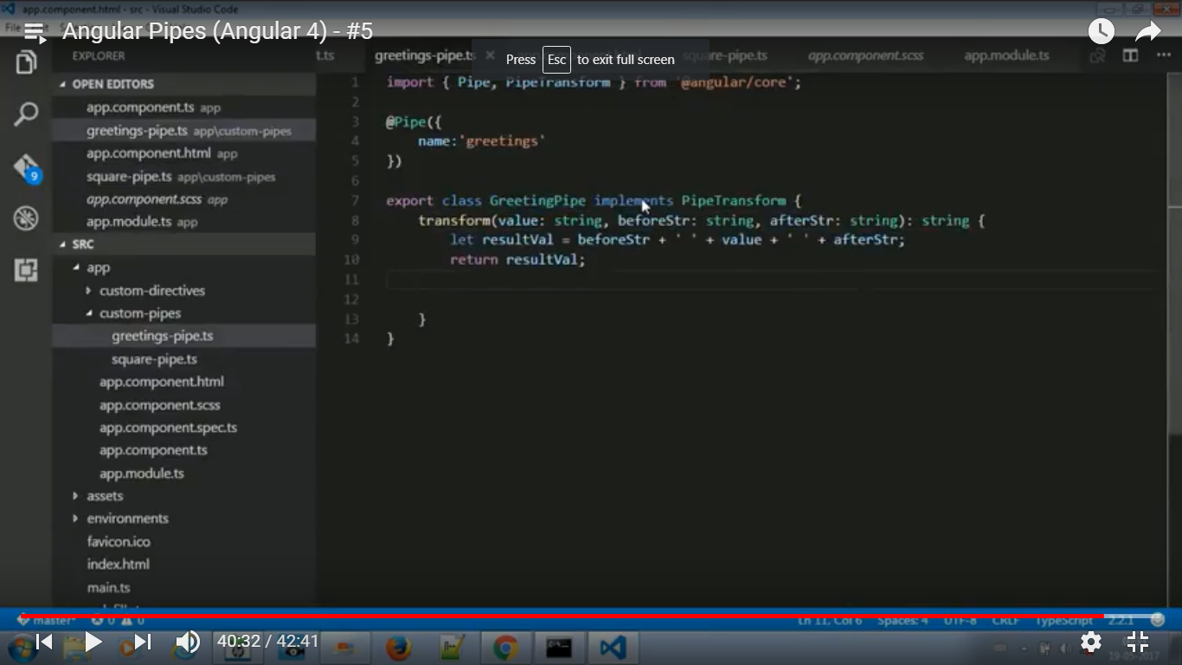

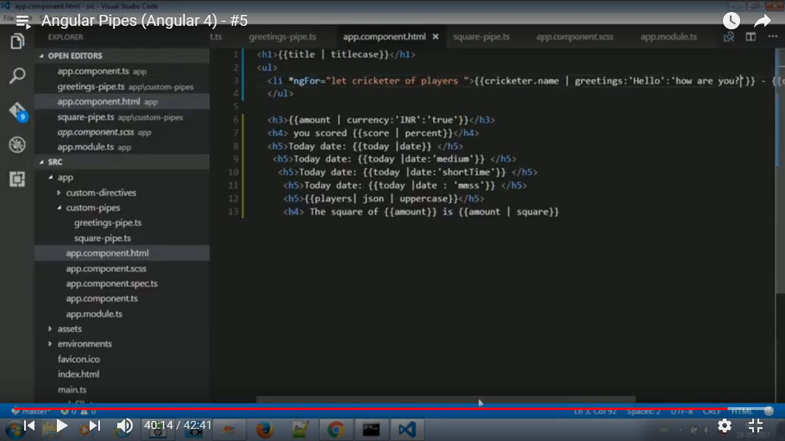

**Q=Ng-for structural directive:**

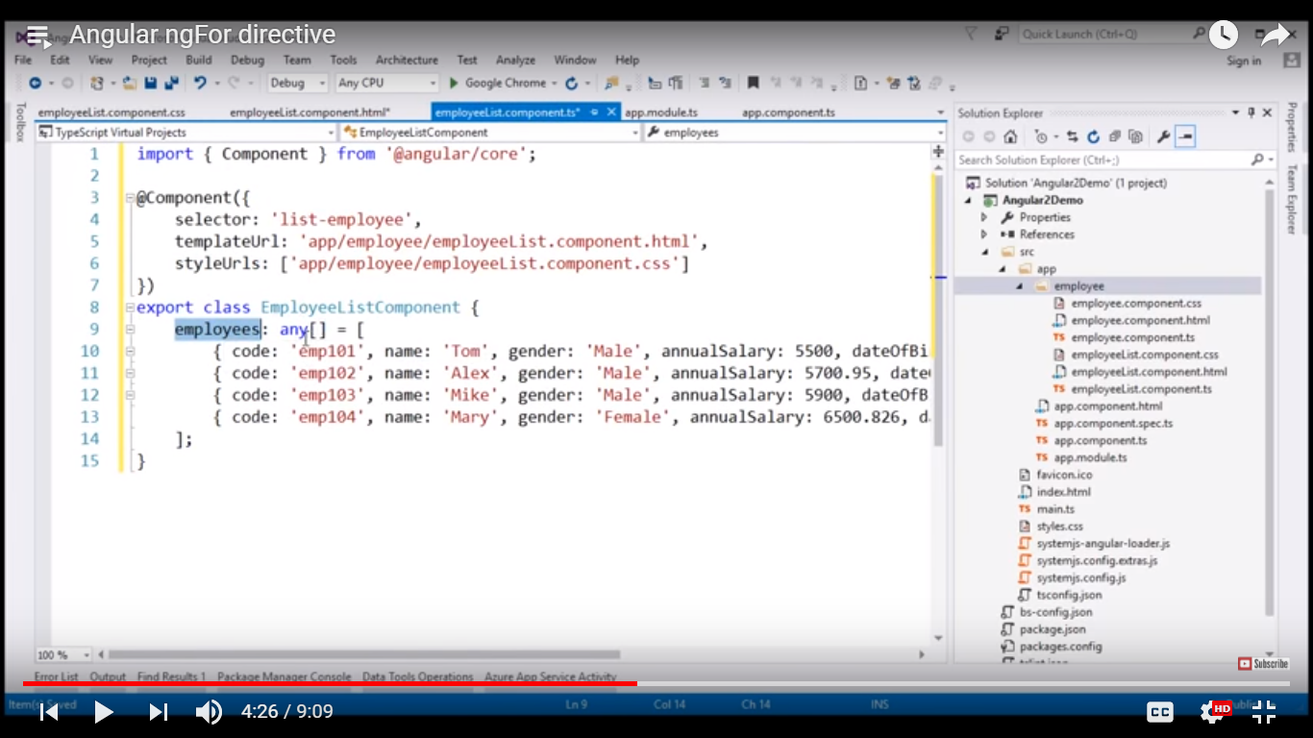

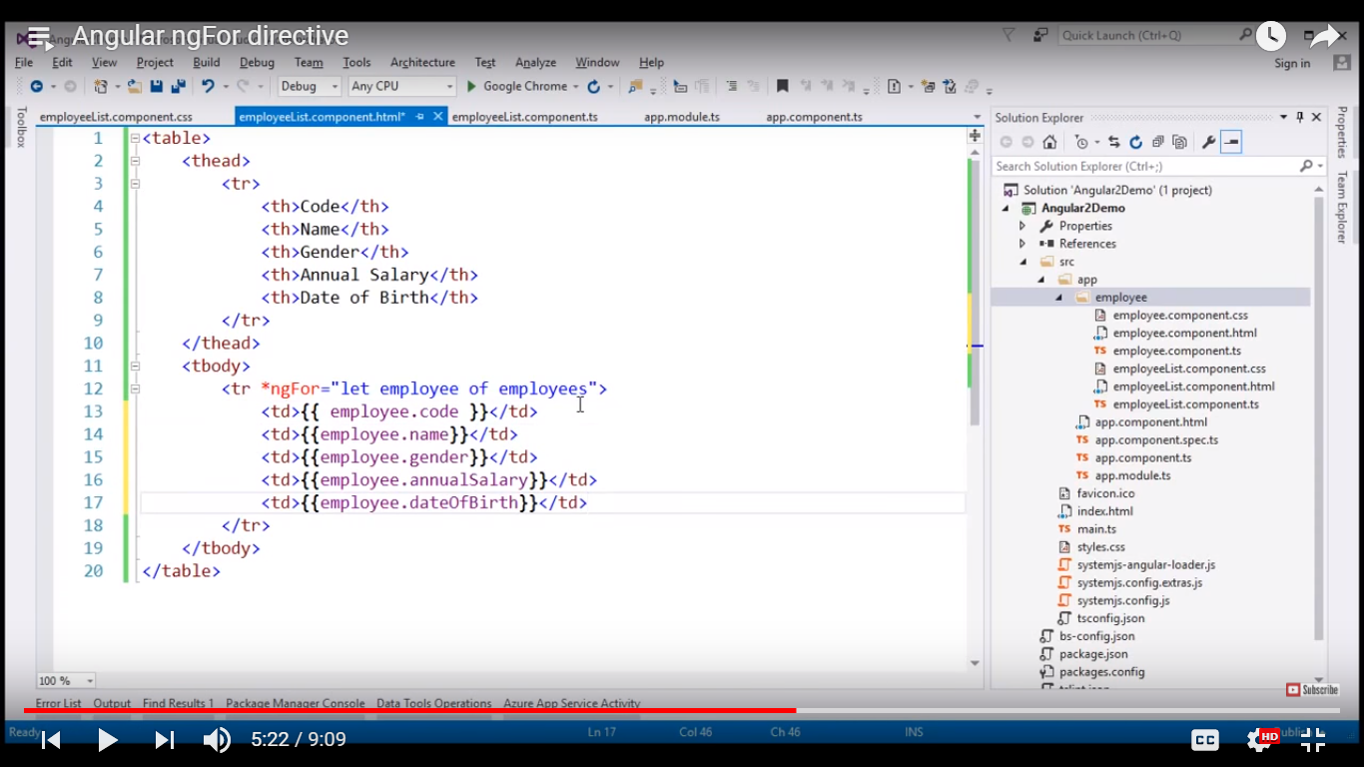

**Main component define the root template with list-employee.**

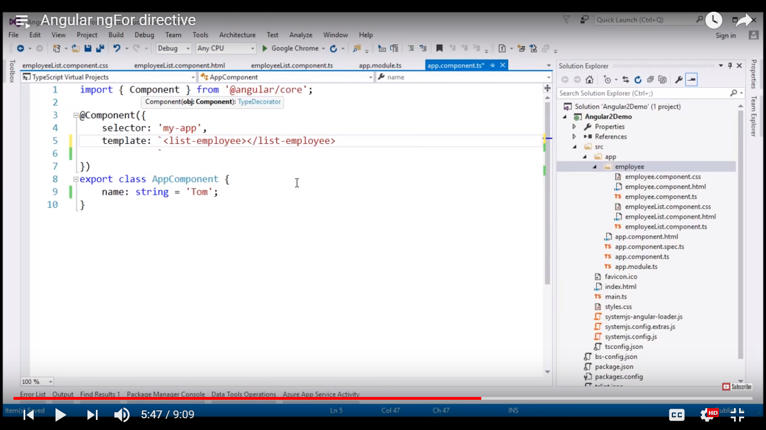

**Resister our EmployeeListComponent in app.module.ts wchich is the main module in angular.**

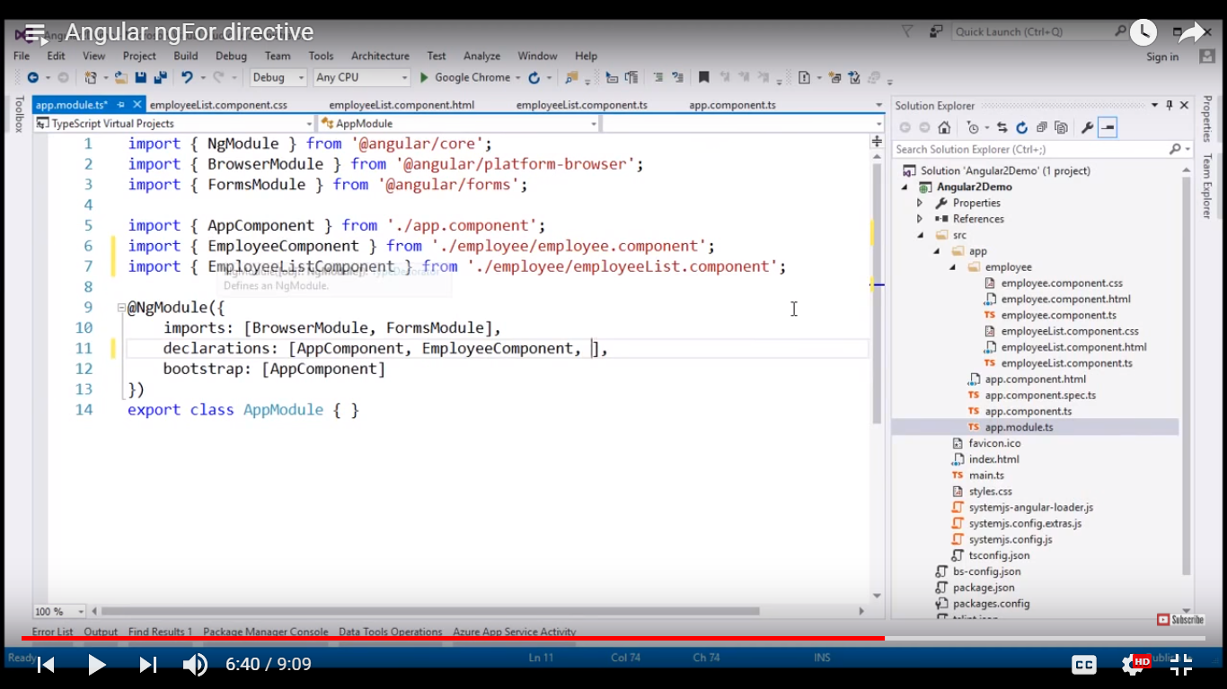

**Apply ng-if if record is not available.**

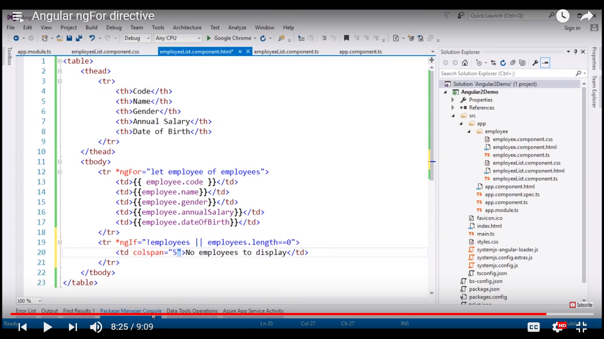

**Angulat ngFor trackBy:**

**Add a method trackByEmpCode**

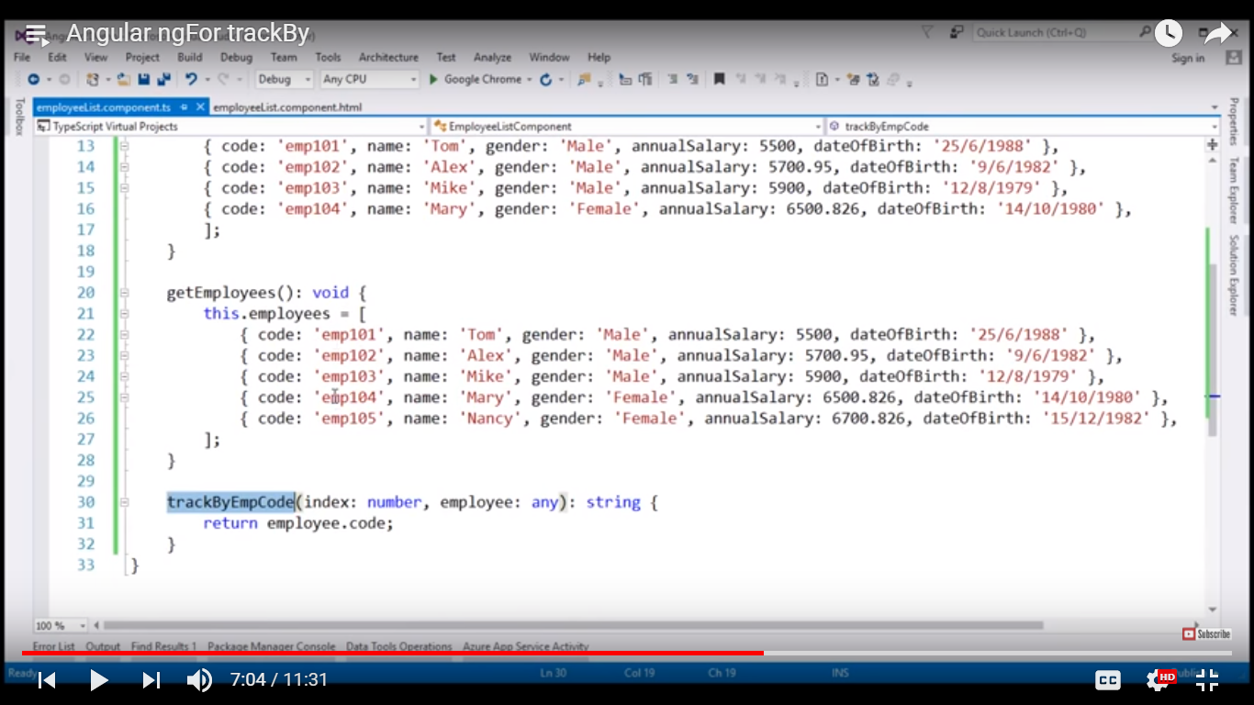

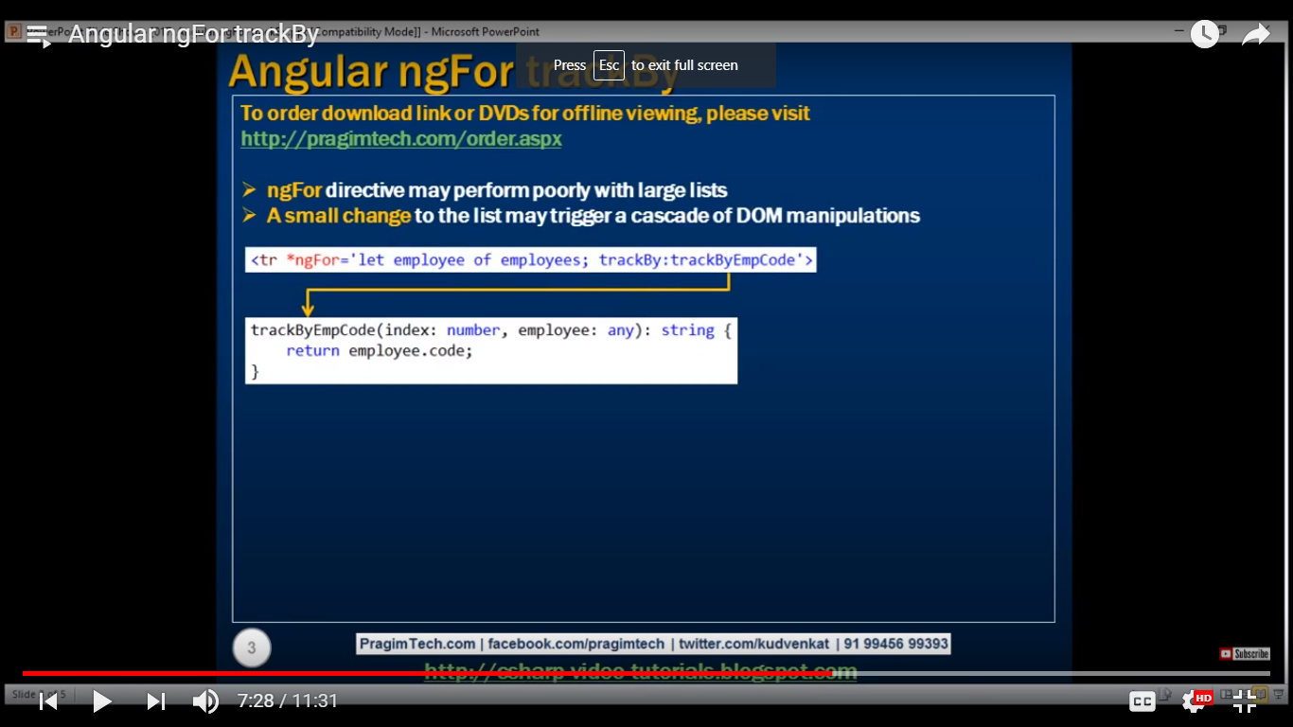

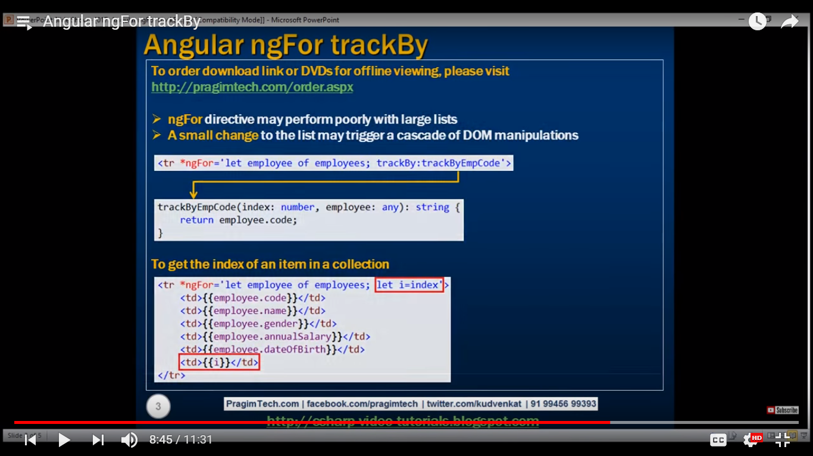



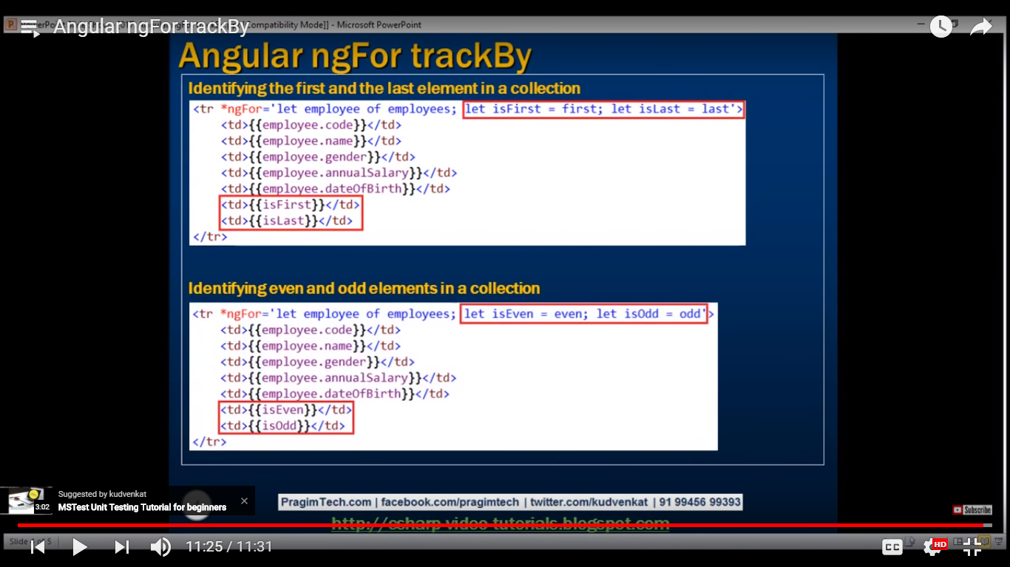

Q=Angular component and nested component?

Ans=

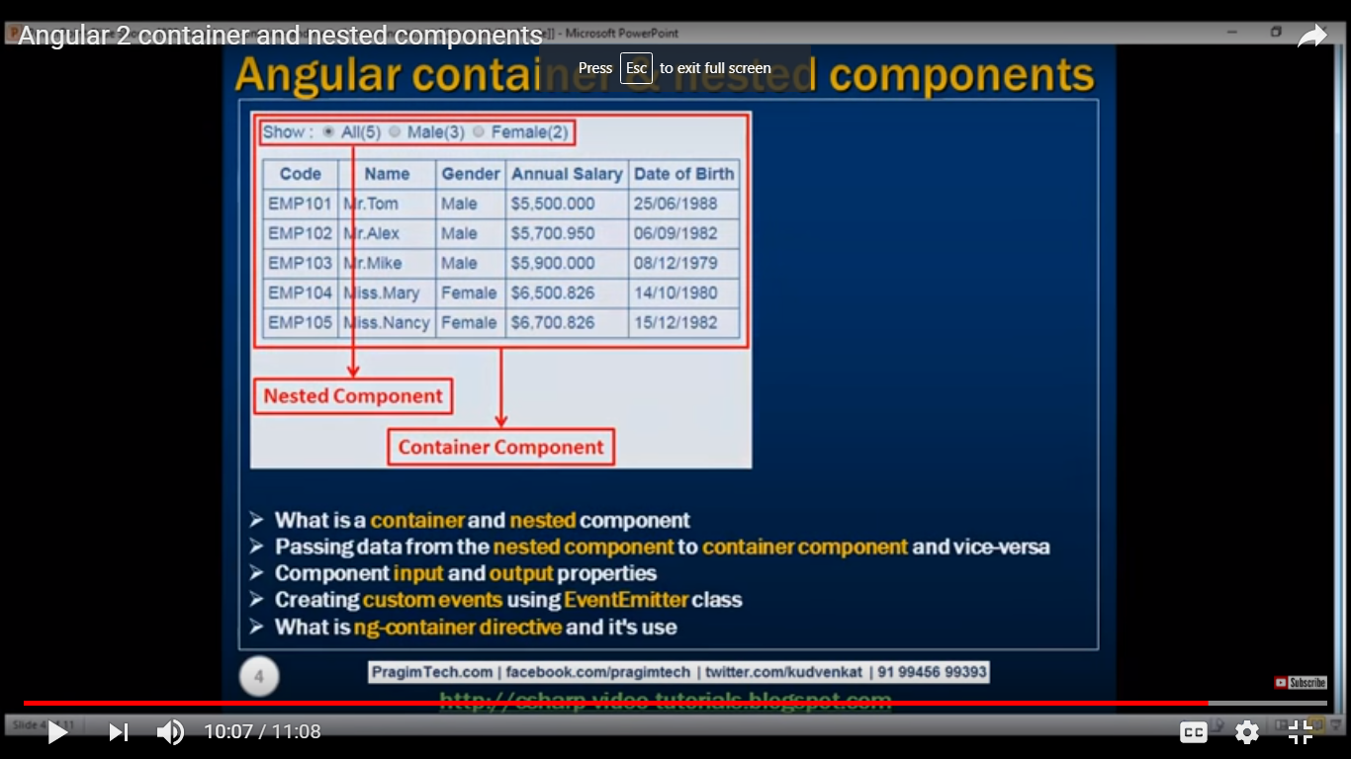

Q=interface in angular2?

Ans= It is just like the java interfaces.

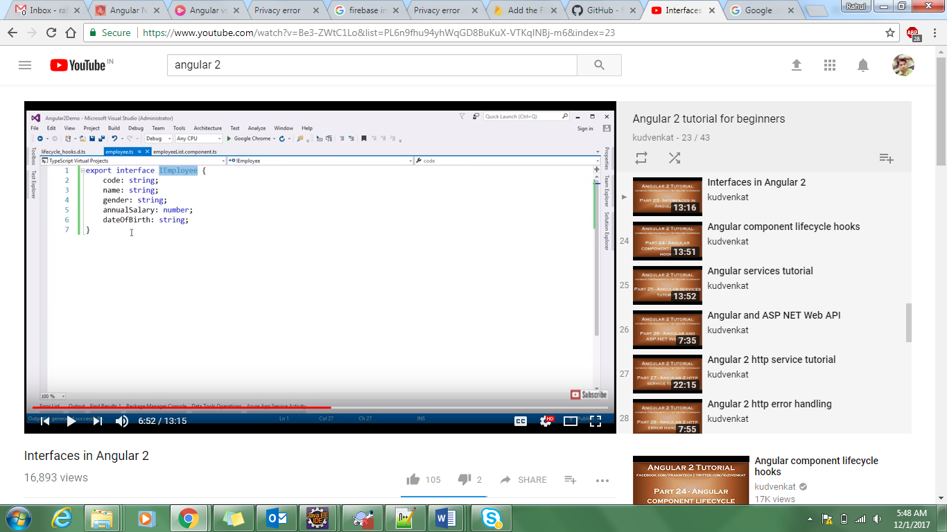

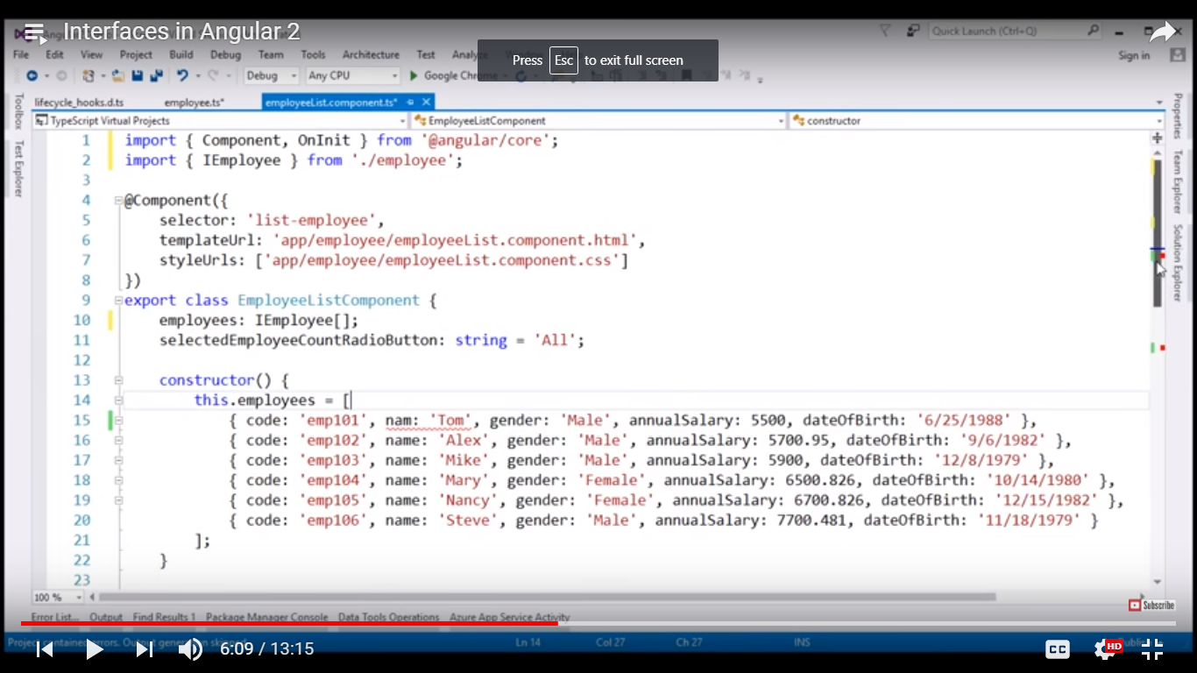

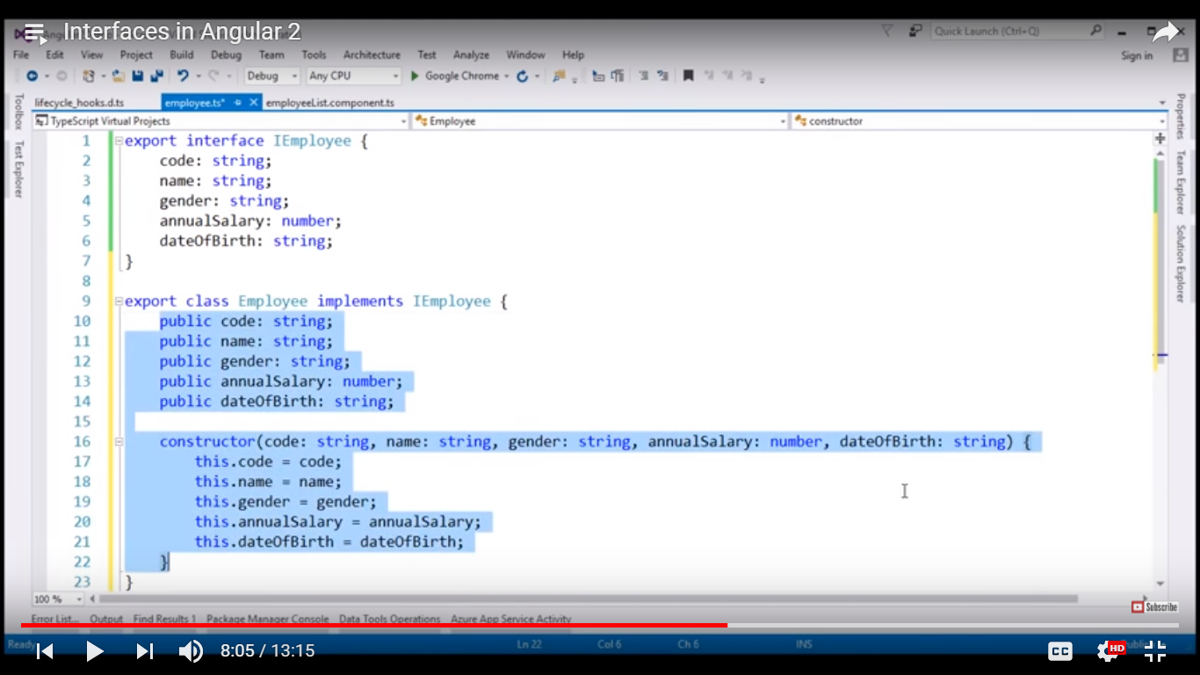

To reduce this code angular provides ur a shortcut syntax.

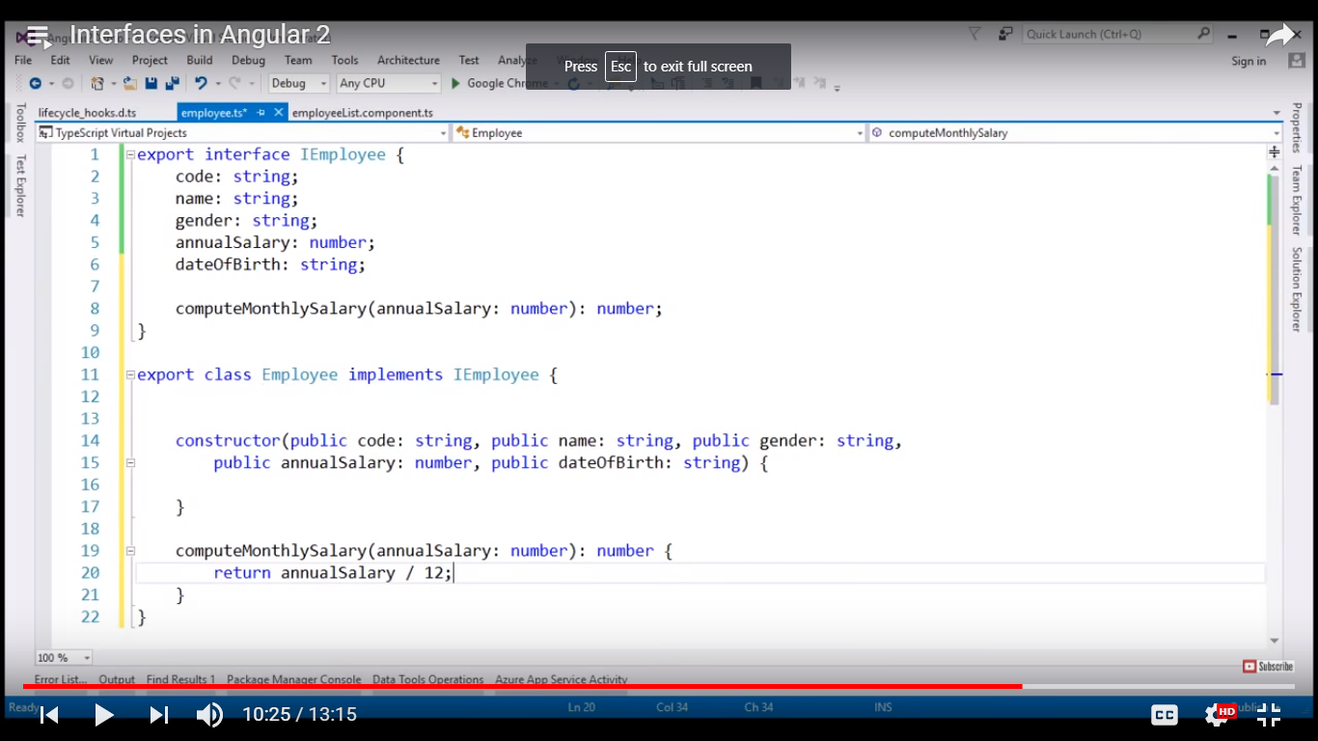

We can add optional properties in angular 2interfaces.

Department?:String

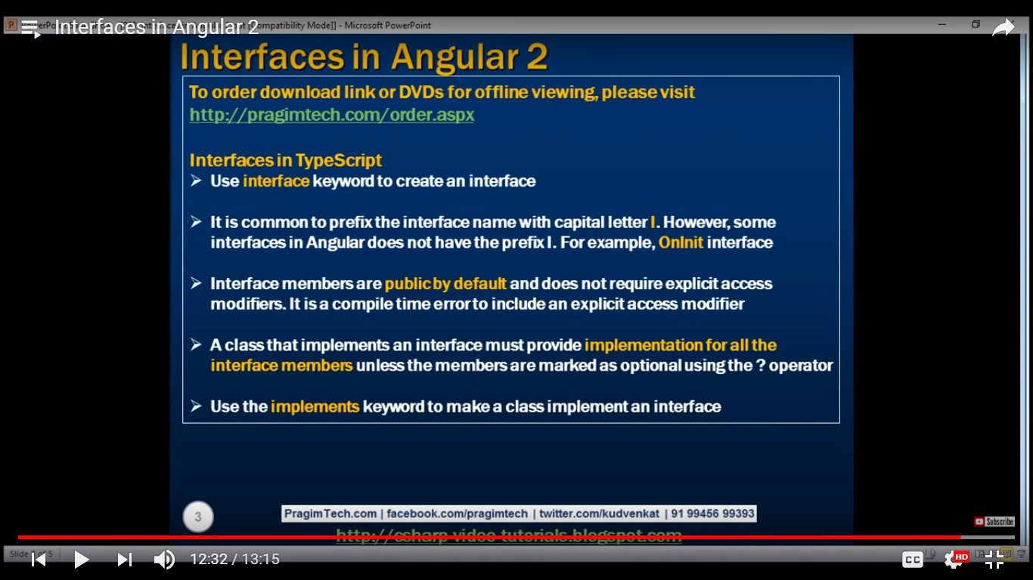

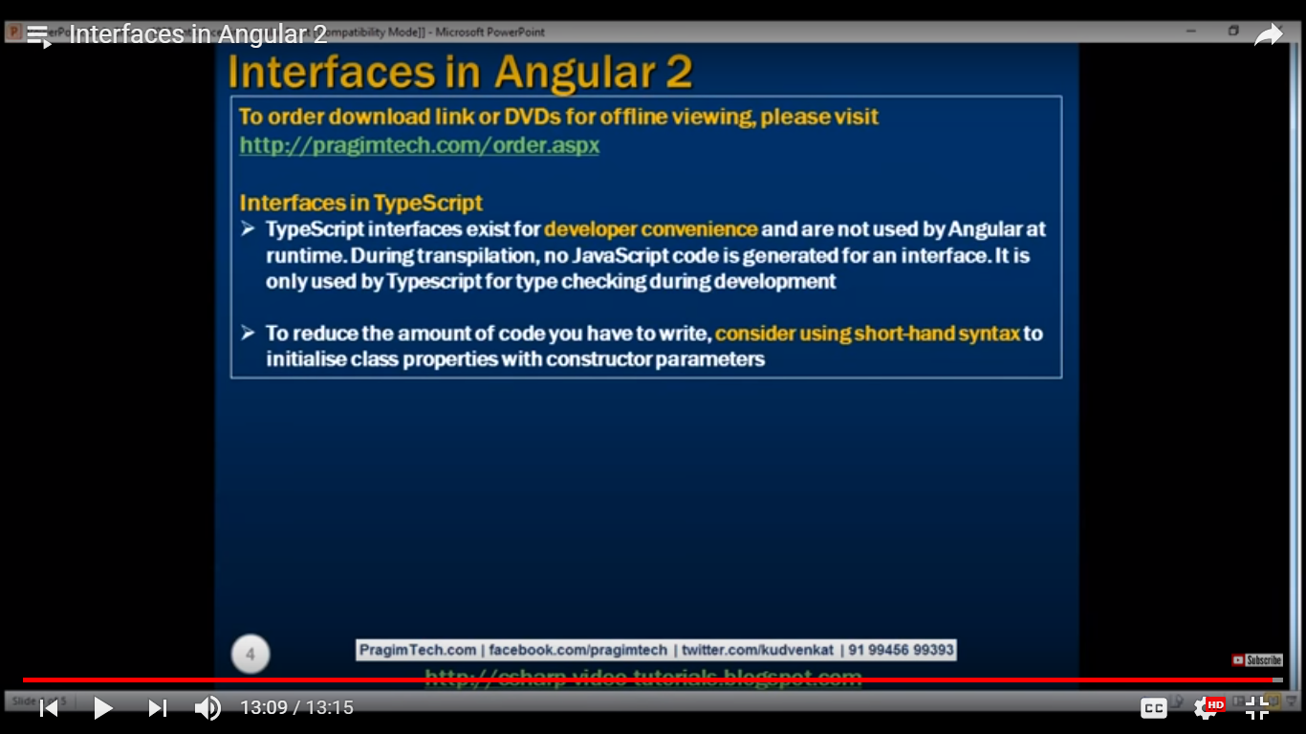

Angular component life cycle :-

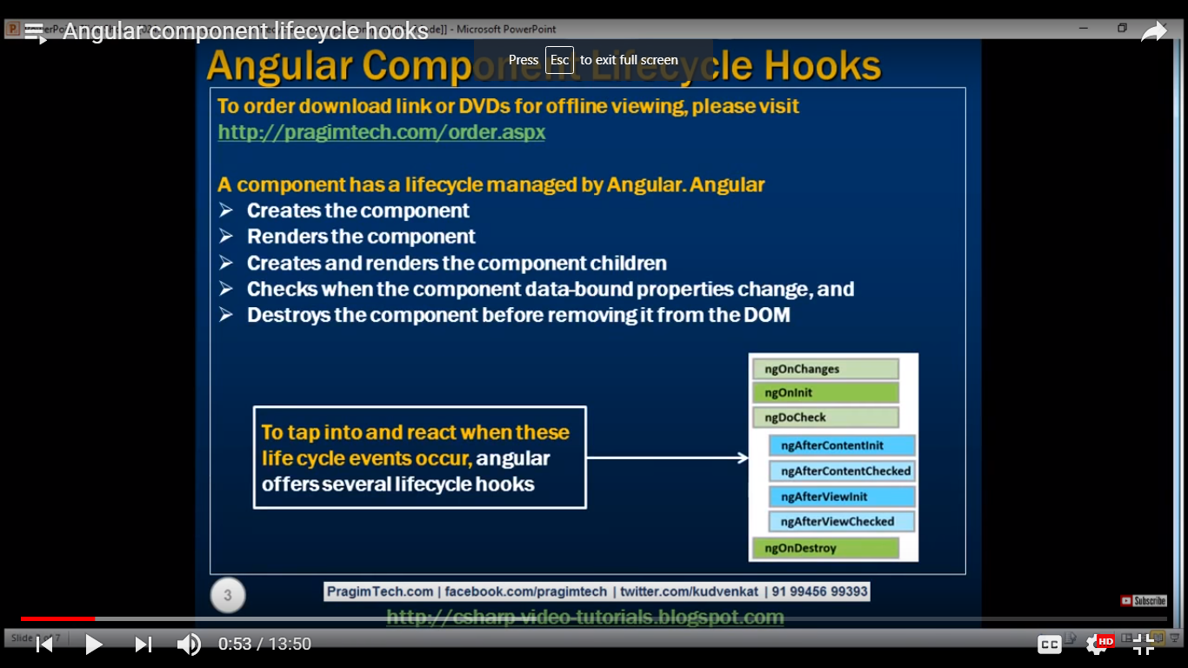

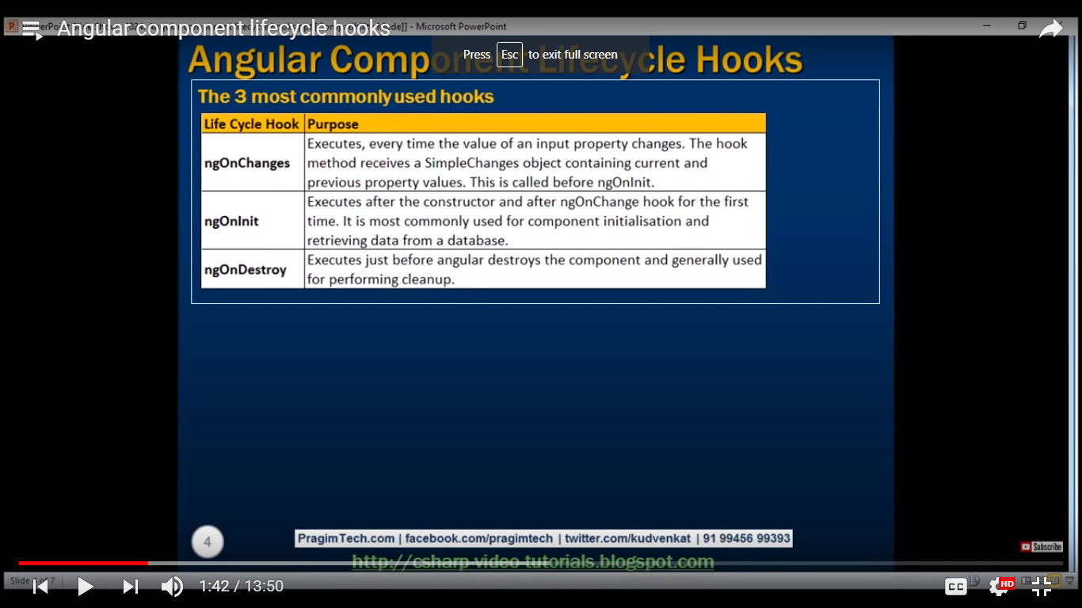

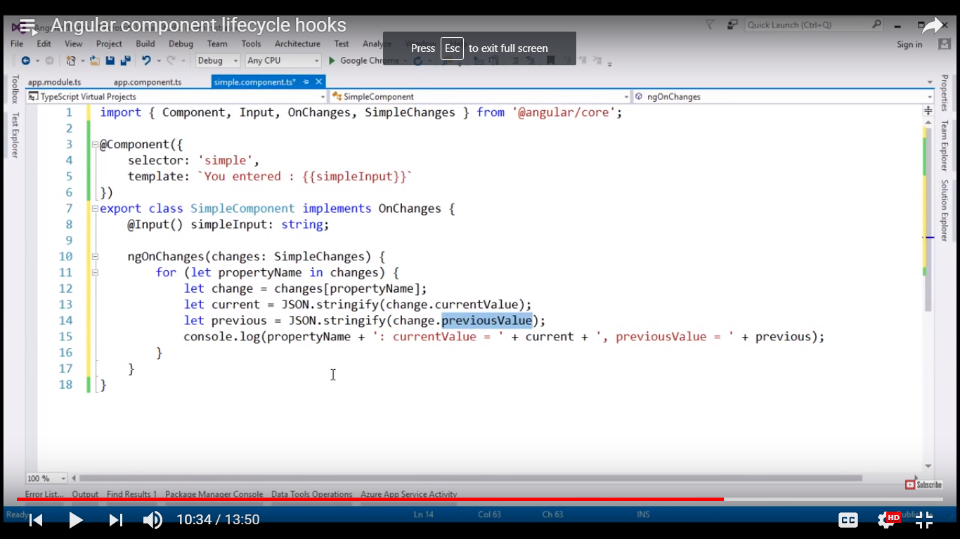

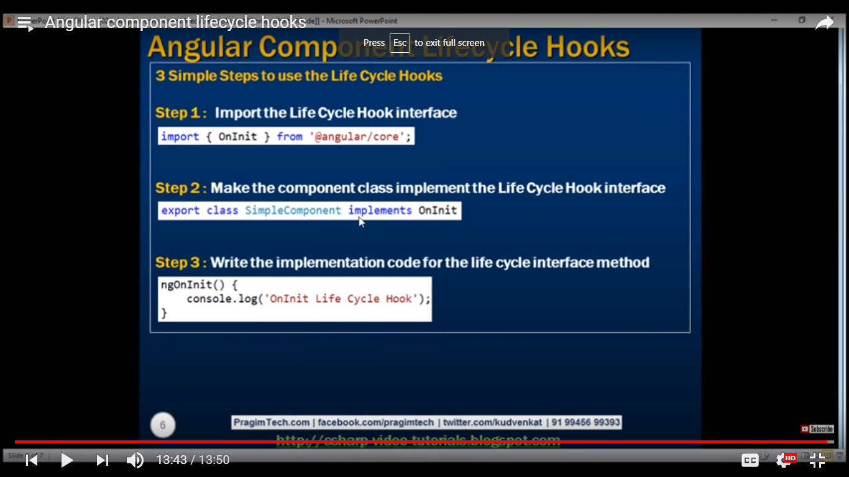

Angularjs services:

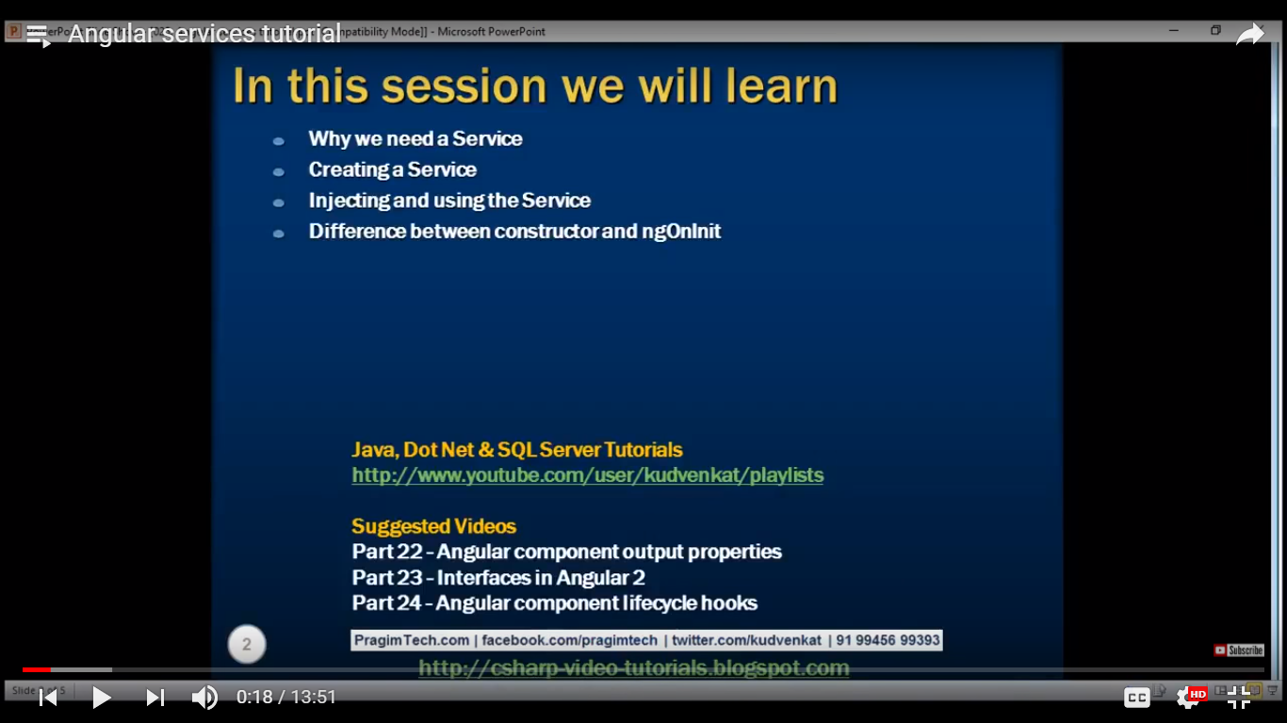

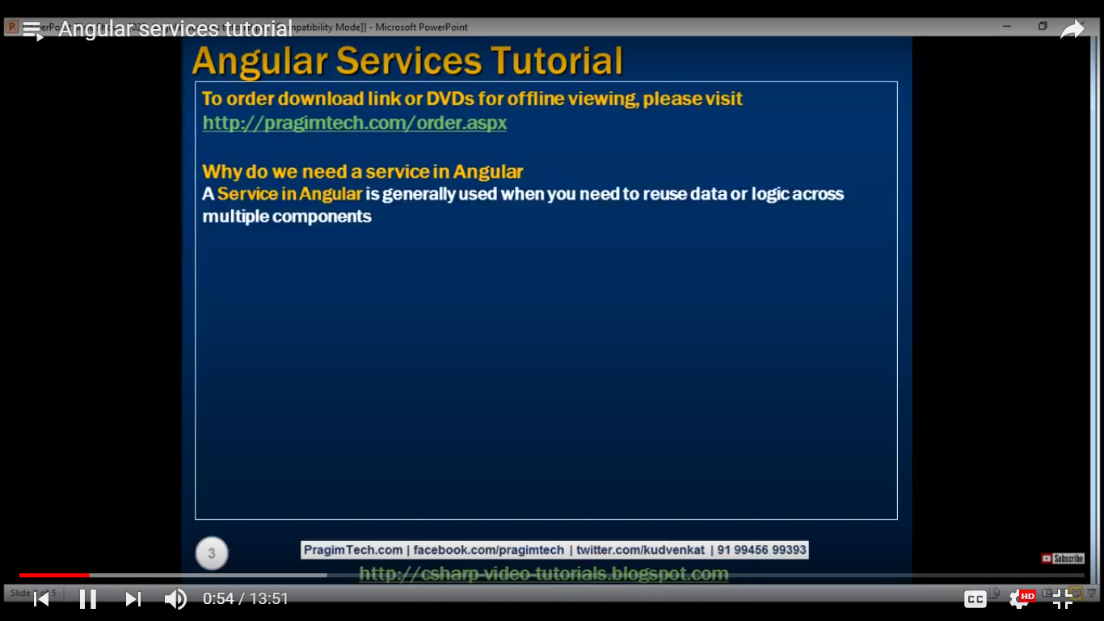

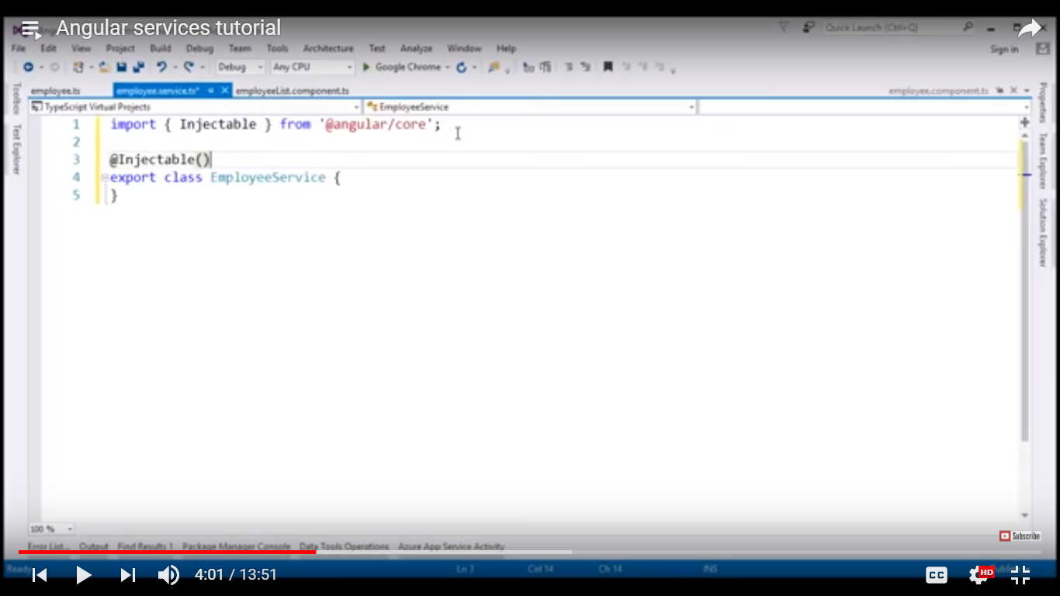

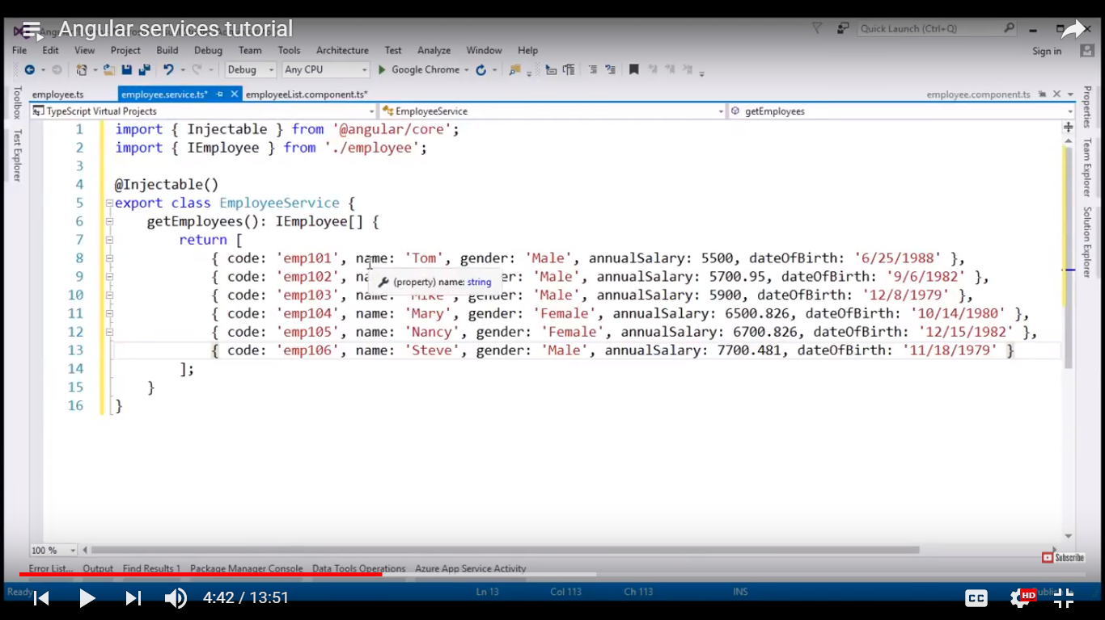

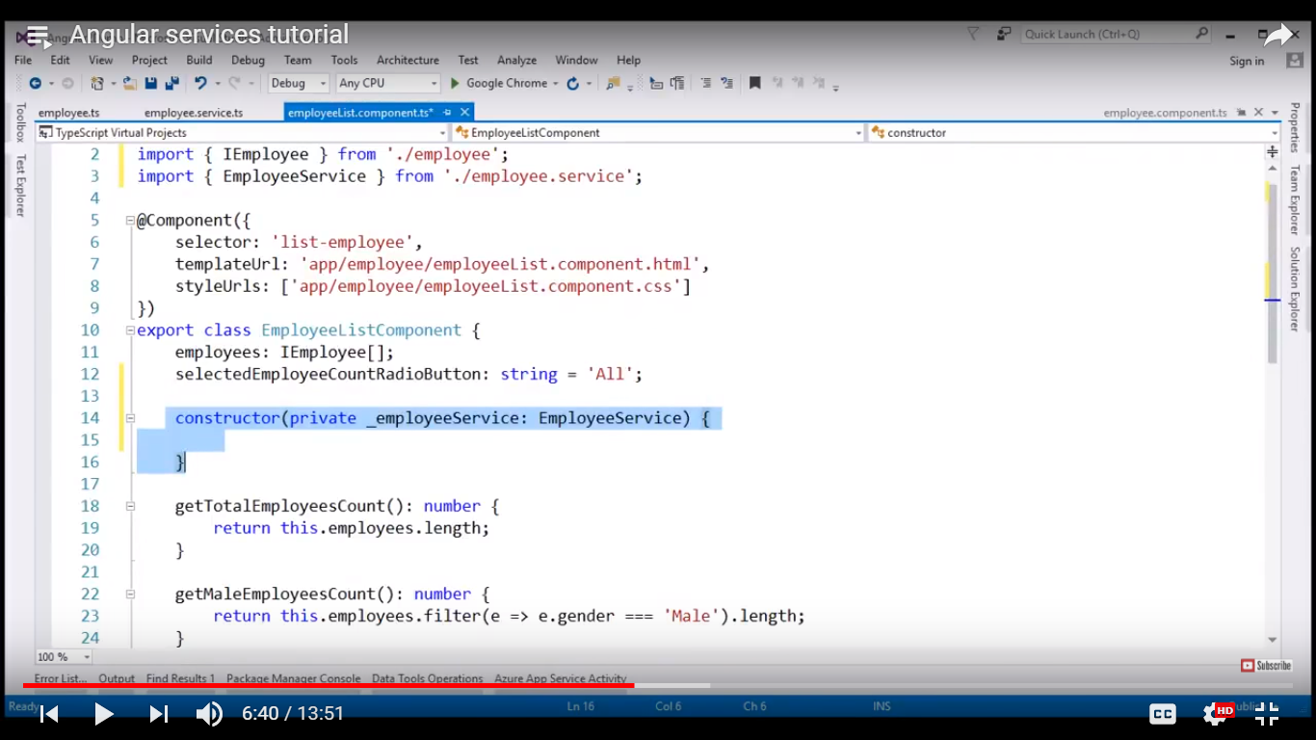

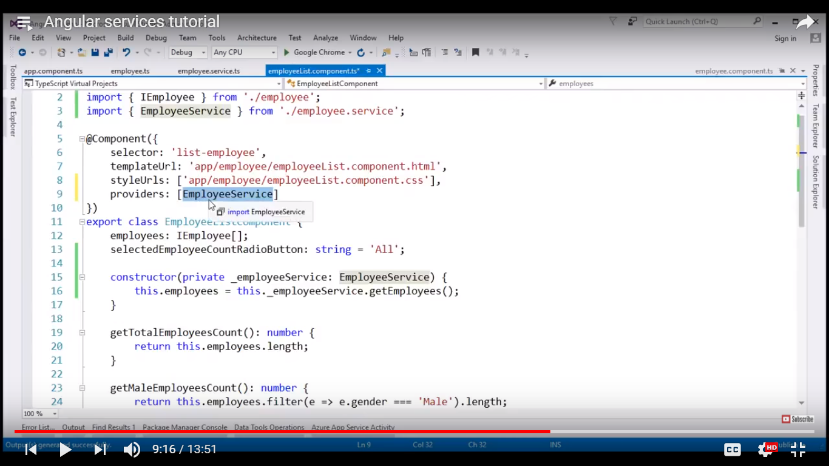

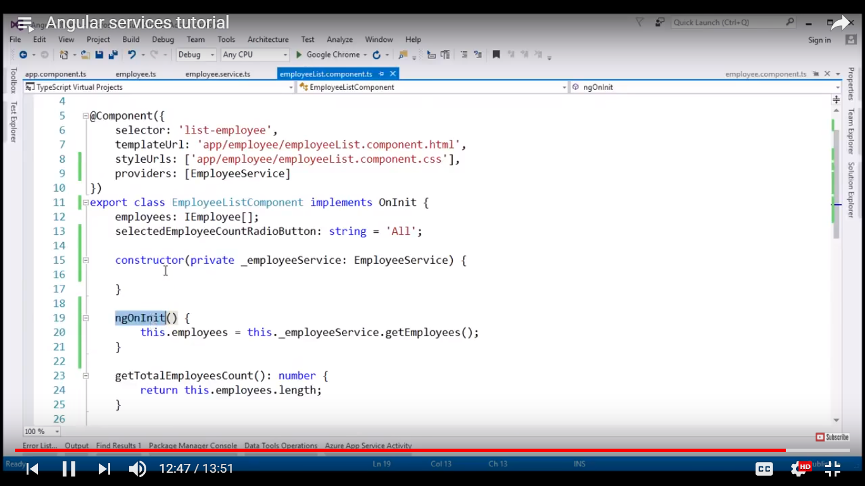

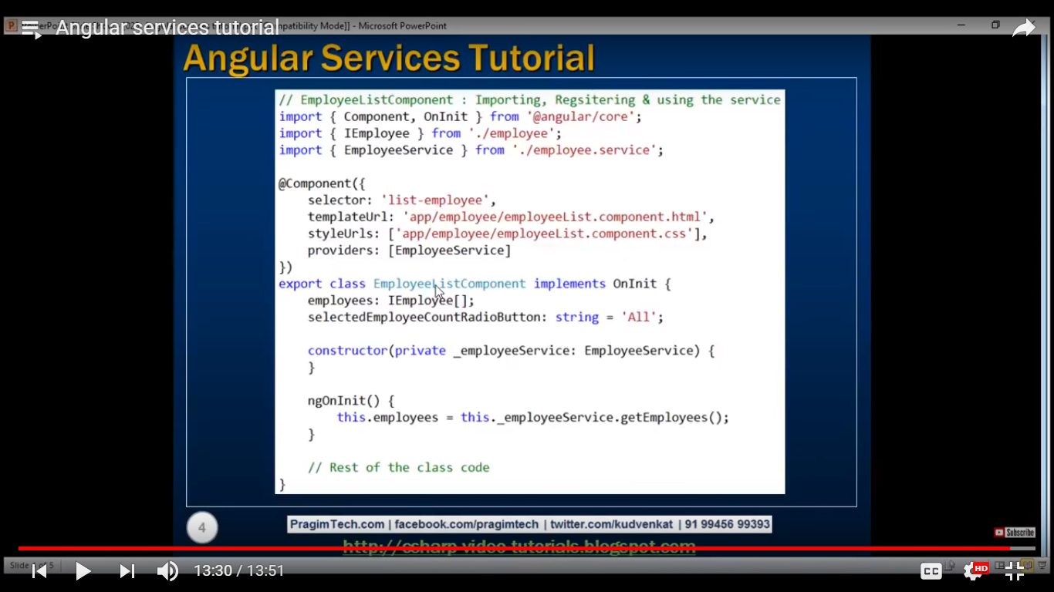

Error handling:

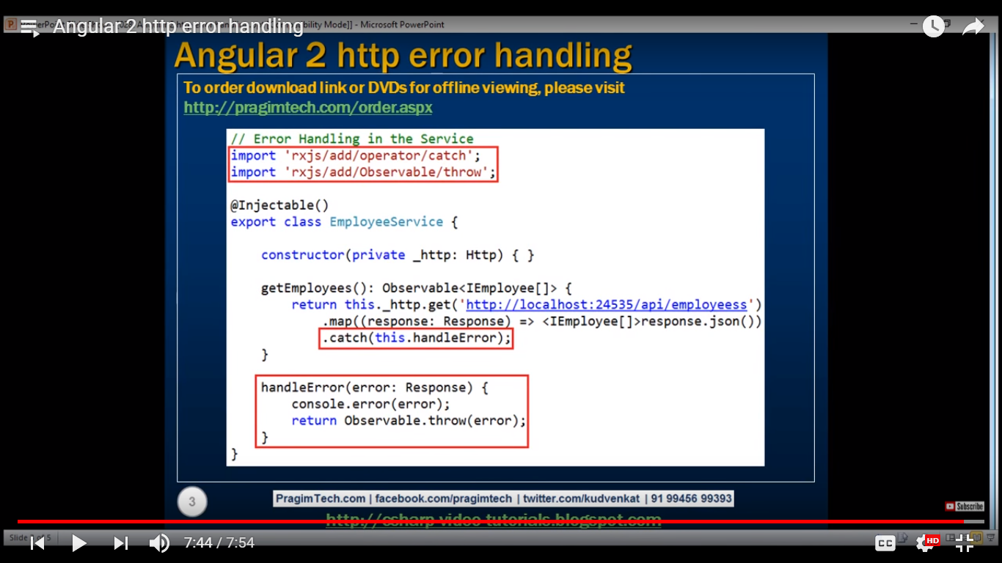

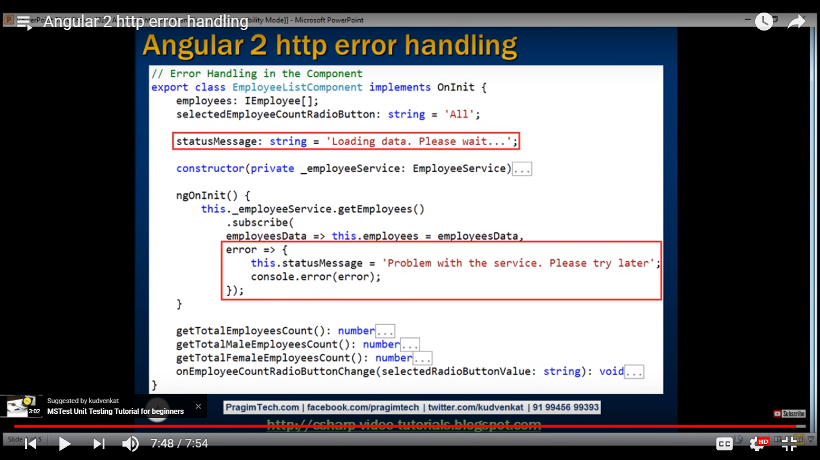

Q=difference between let and var in angular 2?

Ans=https://stackoverflow.com/questions/762011/whats-the-difference-between-using-let-and-var-to-declare-a-variable

|  |  |  |  |
| --- | --- | --- | --- |
| The difference is scoping. var is scoped to the nearest function block and let is scoped to the nearest *enclosing* block, which can be smaller than a function block. Both are global if outside any block.  Also, variables declared with let are not accessible before they are declared in their enclosing block. As seen in the demo, this will throw a ReferenceError exception.  [**Demo**](http://jsfiddle.net/tcCp5/182/)**:**  Show code snippet  Global:  They are very similar when used like this outside a function block.  let me = 'go'; // globally scoped  var i = 'able'; // globally scoped  However, global variables defined with let will not be added as properties on the global windowobject like those defined with var.  console.log(window.me); // undefined  console.log(window.i); // 'able'  Function:  They are identical when used like this in a function block.  function ingWithinEstablishedParameters() {  let terOfRecommendation = 'awesome worker!'; //function block scoped  var sityCheerleading = 'go!'; //function block scoped  }  Block:  Here is the difference. let is only visible in the for() loop and var is visible to the whole function.  function allyIlliterate() {  //tuce is *not* visible out here  for( let tuce = 0; tuce <5; tuce++ ) {  //tuce is only visible in here (and in the for() parentheses)  //and there is a separate tuce variable for each iteration of the loop  }  //tuce is *not* visible out here  }  function byE40() {  //nish *is* visible out here  for( var nish = 0; nish <5; nish++ ) {  //nish is visible to the whole function  }  //nish *is* visible out here  }  Redeclaration:  Assuming strict mode, var will let you re-declare the same variable in the same scope. On the other hand, let will not:  'use strict';  let me = 'foo';  let me = 'bar'; // SyntaxError: Identifier 'me' has already been declared  'use strict';  var me = 'foo';  var me = 'bar'; // No problem, `me` is replaced.   |  |  |  | | --- | --- | --- | | [share](https://stackoverflow.com/a/11444416)[improve this answer](https://stackoverflow.com/posts/11444416/edit) | [edited Jul 28 at 12:01](https://stackoverflow.com/posts/11444416/revisions) | community wiki  [23 revs, 13 users 38%](https://stackoverflow.com/posts/11444416/revisions) [ThinkingStiff](https://stackoverflow.com/users/918414) | |
|  | |  |  |  |  | | --- | --- | --- | --- | | |  |  | | --- | --- | | 44 |  | | So is the purpose of let statements only to free up memory when not needed in a certain block? – [NoBugs](https://stackoverflow.com/users/778234/nobugs" \o "4,827 reputation)[Jun 7 '13 at 5:18](https://stackoverflow.com/questions/762011/whats-the-difference-between-using-let-and-var-to-declare-a-variable#comment24522185_11444416) | | |  |  | | --- | --- | | 61 |  | | @NoBugs, Yes, and it is encouraged that variables are existent only where they are needed. – [batman](https://stackoverflow.com/users/1418853/batman) [Jun 7 '13 at 15:02](https://stackoverflow.com/questions/762011/whats-the-difference-between-using-let-and-var-to-declare-a-variable#comment24540135_11444416) | | |  |  | | --- | --- | | 45 |  | | let block expression let (variable declaration) statement is non-standard and will be removed in future, [bugzilla.mozilla.org/show_bug.cgi?id=1023609](https://bugzilla.mozilla.org/show_bug.cgi?id=1023609). – [Gajus](https://stackoverflow.com/users/368691/gajus) [Dec 17 '14 at 14:51](https://stackoverflow.com/questions/762011/whats-the-difference-between-using-let-and-var-to-declare-a-variable#comment43485109_11444416) | | |  |  | | --- | --- | | 16 |  | |  | |

Q=What is the difference between == and === in JavaScript? I have also seen != and !==operators. Are there more such operators?

The 3 equal signs mean "equality without type coercion". Using the triple equals, the values must be equal in type as well.

0 == false// true

0 === false// false, because they are of a different type

1 == "1"// true, automatic type conversion for value only

1 === "1"// false, because they are of a different type

null == undefined// true

null === undefined// false

'0' == false// true

'0' === false// false

* == attempts to convert the values to the same type before testing if they're the same. "5" == 5
* === does not do this; it requires objects to be of the same type to be equal. "5" !== 5

In this case, the result is:

* x == undefined will be true if x is undefined or null.
* x === undefined will only be true if x is undefined.

Q=Two way data binding?

Ans=

Q=difference between let and var keyword in angular?

**Attribute binding:**

<th [attr.colspan] = ‘column span’></th>

Or

<th attr.colspan = {{column span}}></th>

**Event Binding:**

**E**vent binding flows data in the opsite direction i.e. from an html element to a component:

<button (click) = ‘onClick()’> Click Me </button>

Even binding alternative syntax (canonical form)

<button on-click = ‘onclick()’> Click Me </button>

**Ng if:**

<tr *ngIf=”showDetails”>

<td>Gender></td>

</tr>

Export class EmployeeComponent{

showDetails:Boolean = false;

toggleDetails() : void{

this.showDetails = !this.showdetails;

}

}

<button>{{showDetails > hide : show}} Details< /button>

*ngIf is a structural directive

**Two way databinding:**

**Import {component} from ‘angular/core’;**

**@Component{{**

**Selector : ‘my-app’,**

**Template:’**

**Name : <input [value] = ‘name’ (input)=$event.target.value/>**

**<br/>**

**You entered: {{name}}**

**’}}**

**export class Eppcomponent{**

**name:String=’Tom’**

**}**

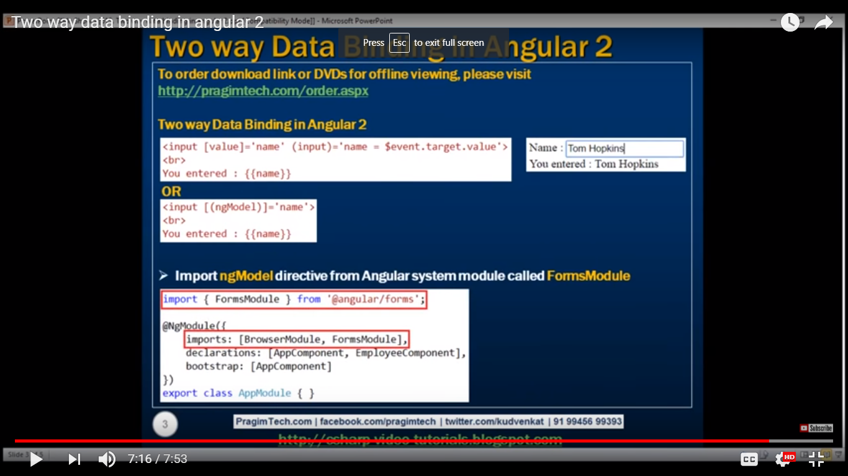

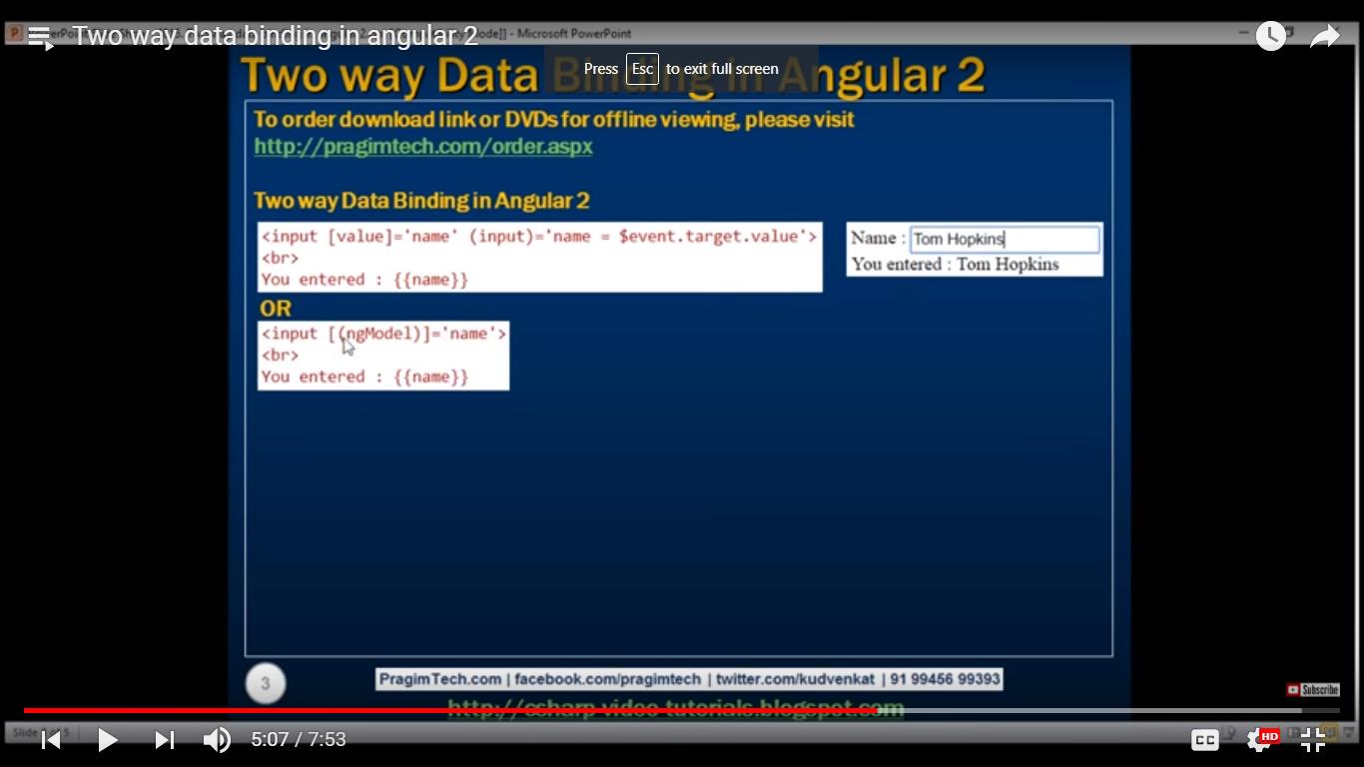

**Angular interface:**

exportinterfaceIEmployee{

code:string;

name:string;

gender:string;

annualSalary:string;

dataOfBirth:string;

department?:string; //optional property using ‘?’ (means if we will not implements in implemented class then there is no error )

computeMonthalySalary(annualSalary: number) : number;

}

exportclassEmployeeimplementsIEmployee{

constructor(publiccode:string,publicname:string, publicgender: string, publicannualSalary:string,publicdataOfBirth:string){

}

computeMonthalySalary(annualSalary: number) : number{

returnannualSalary/12;

}

}

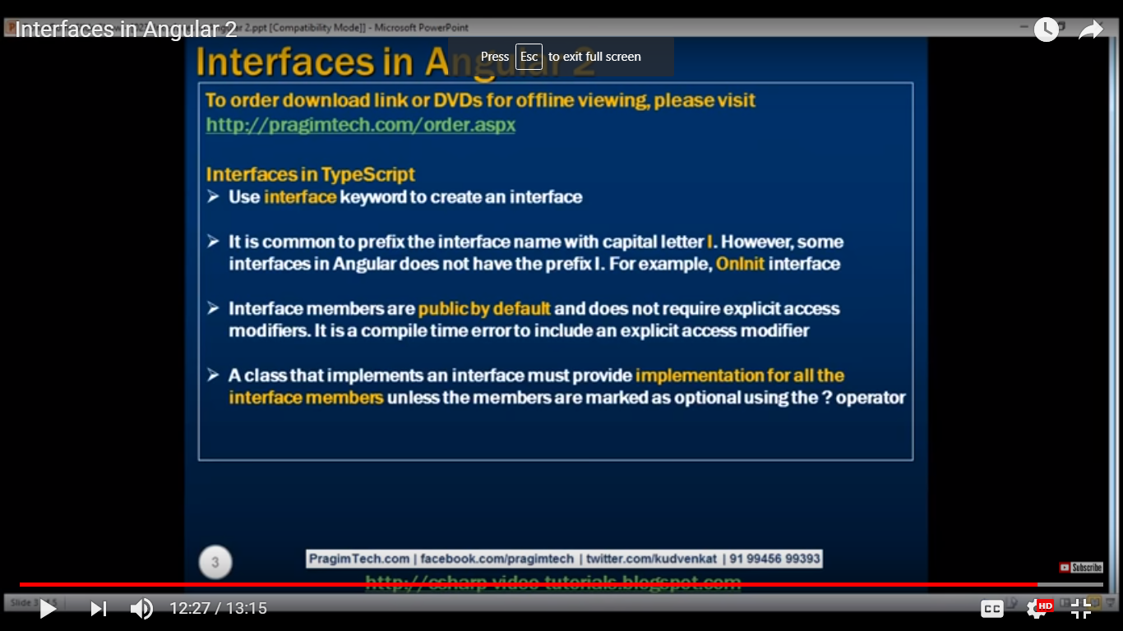

**Angular Life Cycle:**

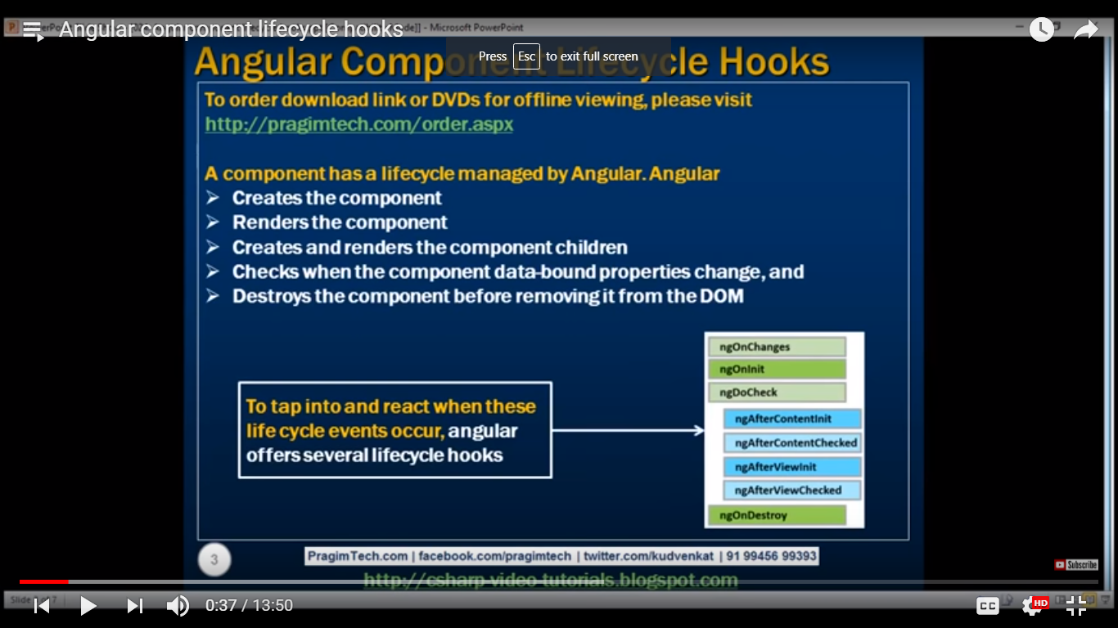

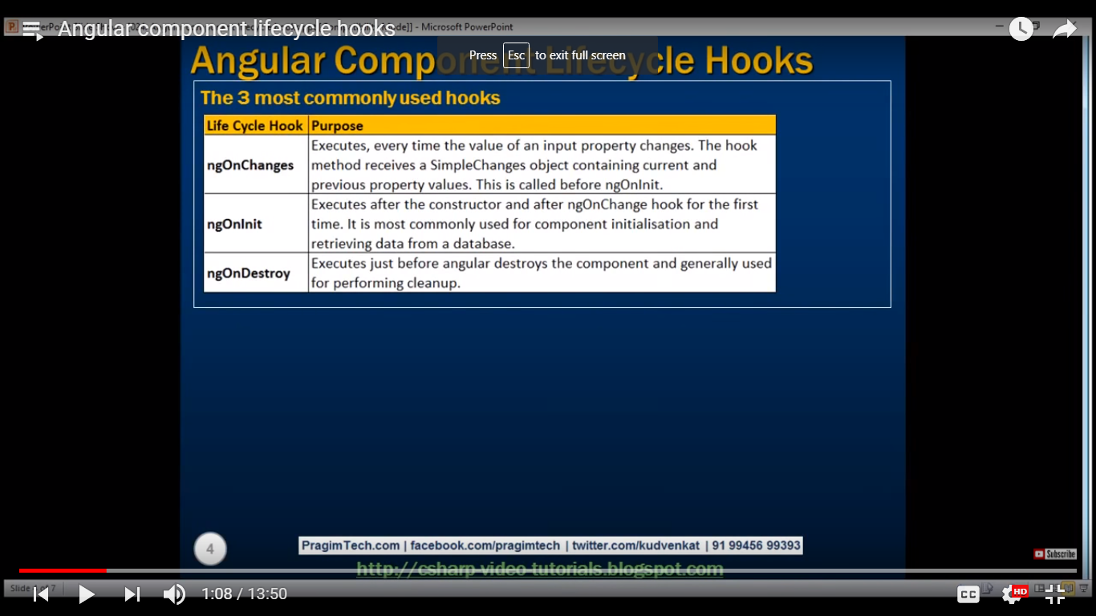

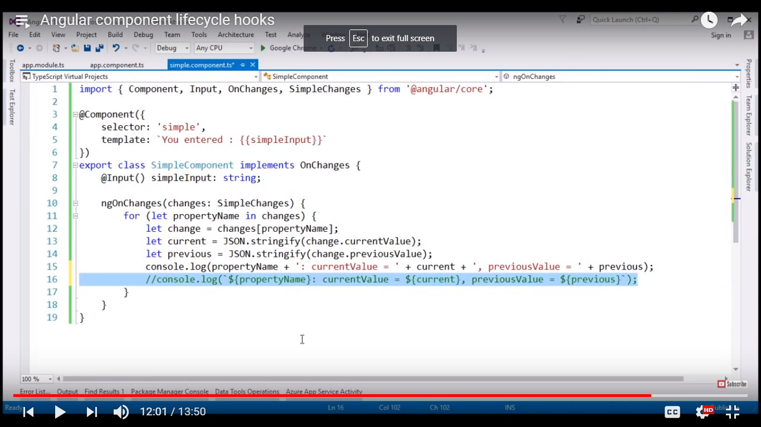

**Angular service:**

**Import {injectable} from ‘@angular/core’**

Import {IEmployee} from ‘./employee’

@injectable

Export class EmployeeService{

}

Q=async pipe?

Ans= It unwraps a value from an asynchronous primitive. If we have Observable or Promise instance then we use it directly with AsyncPipe using directive such as NgFor, NgIfand NgSwitch. AsyncPipe belongs to angular common module. AsyncPipe subscribes to Observable or Promise and returns the latest data. It plays the role that marks the component to check for data changes. AsyncPipe is used as follows.

<div>{{ observableTime | async }} </div>

**book.service.ts**

import{Injectable}from'@angular/core';

import{Http,Response}from'@angular/http';

import{Observable,Subscriber}from'rxjs';

import'rxjs/add/operator/map';

import'rxjs/add/operator/toPromise';

import{Book}from'./book';

@Injectable()

exportclassBookService{

url ="http://localhost:4200/data/books.json";

constructor(private http:Http){}

//Returns Observable<Book[]>

getBooksWithObservable():Observable<Book[]>{

returnthis.http.get(this.url).map((res:Response)=> res.json());

}

//Returns Promise<Book[]>

getBooksWithPromise():Promise<Book[]>{

returnthis.http.get(this.url).toPromise().then((res:Response)=> res.json());

}

//Returns Observable<string>

getCurrentTime():Observable<string>{

returnnewObservable<string>((observer:Subscriber<string>)=>{

//1 second interval

setInterval(()=> observer.next(newDate().toString()),1000);

});

}

//Returns Promise<Book>

getBookSlowly():Promise<Book>{

returnnewPromise(resolve =>{

let book =newBook();

book.id=100;

book.name='jQuery Tutorials';

// Delay by 3 second

setTimeout(()=> resolve(book),3000);

});

}

}

Find dummy JSON file and class that will hold data.   
**books.json**

[

{"id":1,"name":"Core Java"},

{"id":2,"name":"Angular 2"},

{"id":3,"name":"Hibernate"},

{"id":4,"name":"Spring"}

]

**book.ts**

exportclassBook{

id: number;

name:string;

constructor(){

}

}

AsyncPipe with Observable using NgFor

Here we will use AsyncPipe with Observable using NgFor as follows.   
**observable.component.html**

<h3>AsyncPipe with Observable using NgFor</h3>

<ul>

<li *ngFor="let book of observableBooks | async">

Id: {{book.id}}, Name: {{book.name}}

</li>

</ul>

**observable.component.ts**

import{Component,OnInit}from'@angular/core';

import{Observable}from'rxjs';

import{BookService}from'./book.service';

import{Book}from'./book';

@Component({

selector:'app-observable',

templateUrl:'./observable.component.html'

})

exportclassObservableComponentimplementsOnInit{

observableBooks:Observable<Book[]>

constructor(private bookService:BookService){}

ngOnInit():void{

this.observableBooks =this.bookService.getBooksWithObservable();

}

}

AsyncPipe with Promise using NgFor

Here we will use AsyncPipe with Promise using NgFor as follows.   
**promise.component.html**

<h3>AsyncPipe with Promise using NgFor</h3>

<ul>

<li *ngFor="let book of promiseBooks | async">

Id: {{book.id}}, Name: {{book.name}}

</li>

</ul>

**promise.component.ts**

import{Component,OnInit}from'@angular/core';

import{BookService}from'./book.service';

import{Book}from'./book';

@Component({

selector:'app-promise',

templateUrl:'./promise.component.html'

})

exportclassPromiseComponentimplementsOnInit{

promiseBooks:Promise<Book[]>

constructor(private bookService:BookService){}

ngOnInit():void{

this.promiseBooks =this.bookService.getBooksWithPromise();

}

}

AsyncPipe with NgIf and NgSwitch

Find AsyncPipe with NgIf and NgSwitch.   
**data.component.html**

<h3>AsyncPipe with NgIf</h3>

<div *ngIf="promiseBook | async as book; else loading">

Id: {{book.id}}, Name: {{book.name}}

</div>

<ng-template #loading>Loading Data...</ng-template>

<h3>AsyncPipe with NgSwitch</h3>

<div [ngSwitch]="(promiseBook | async)?.id">

<div *ngSwitchCase="100">Find Actual Data</div>

<div *ngSwitchDefault>Showing Default Data</div>

</div>

**data.component.ts**

import{Component,OnInit}from'@angular/core';

import{BookService}from'./book.service';

import{Book}from'./book';

@Component({

selector:'app-data',

templateUrl:'./data.component.html'

})

exportclassDataComponentimplementsOnInit{

promiseBook:Promise<Book>

constructor(private bookService:BookService){}

ngOnInit():void{

this.promiseBook =this.bookService.getBookSlowly();

}

}

AsyncPipe with Date

Find AsyncPipe to display current date and time.   
**time.component.html**

<h3>AsyncPipe with Date</h3>

<div>{{ observableTime | async }} </div><br/>

<div>{{ observableTime | async | date : 'mediumTime' }} </div>

**time.component.ts**

import{Component,OnInit}from'@angular/core';

import{Observable}from'rxjs';

import{BookService}from'./book.service';

@Component({

selector:'app-time',

templateUrl:'./time.component.html'

})

exportclassTimeComponentimplementsOnInit{

observableTime:Observable<string>

constructor(private bookService:BookService){}

ngOnInit():void{

this.observableTime =this.bookService.getCurrentTime();

}

}

Application Component and Module

Find the application component and module.   
**app.component.ts**

import{Component}from'@angular/core';

@Component({

selector:'app-root',

template:`

<app-observable></app-observable>

<app-promise></app-promise>

<app-data></app-data>

<app-time></app-time>

`

})

exportclassAppComponent{

}

**app.module.ts**

import{NgModule}from'@angular/core';

import{BrowserModule}from'@angular/platform-browser';

import{HttpModule}from'@angular/http';

import{AppComponent}from'./app.component';

import{ObservableComponent}from'./observable.component';

import{PromiseComponent}from'./promise.component';

import{TimeComponent}from'./time.component';

import{DataComponent}from'./data.component';

import{BookService}from'./book.service';

@NgModule({

imports:[

BrowserModule,

HttpModule

],

declarations:[

AppComponent,

ObservableComponent,

PromiseComponent,

TimeComponent,

DataComponent

],

providers:[

BookService

],

bootstrap:[

AppComponent

]

})

exportclassAppModule{}